CONTINUING PROFESSIONAL DEVELOPMENT OF PRESCHOOL TEACHERS IN MONTENEGRO

DESK REVIEW

I
1.1 Quality of early and preschool education and professional development of preschool teachers - European perspective

The debate about the quality of early and preschool education, its aspects, ways of achieving it, and its assessment has been ongoing from the nineties to the present day (Dahlberg, Moss, & Pence, 2005, 2007; Dahberg, Moss, 2005). On the other side, quality is inseparably being considered from the perspective of preschool teachers, and very often from the perspective of their professional development (ISSA Principles of Quality Pedagogy).

Proposal for Key principles of a Quality Framework for Early Childhood Education and Care (hereinafter referred to as the European Quality Framework) and ISSA Principles of Quality Pedagogy (hereinafter referred to as the Principles of Quality Pedagogy) shall serve as a basis of our study. In its formal sense, it is more than logical to rely on the European quality perspective because of the efforts Montenegro invests to bring its ECE services closer to the requirements and recommendations of the European Union. The European Quality Framework includes several aspects of quality, professional development staff being one of the very explicitly elaborated and operationalized through its two indicators. In addition to this, European Quality Framework represents a broadly set concept, allowing for certain contouring depending on the context, that is, in this particular case – the features of the context of preschool education in Montenegro.

European Quality Framework identifies five action areas action to be dealt with in order to improve the quality of ECEC: accessibility/coverage, workforce, curriculum, monitoring and evaluation, and governance and funding (European Quality Framework: 6). It also highlights that the working conditions and professional development of preschool teachers are connected with both cognitive and non-cognitive developmental outcomes in children (European Quality Framework: 28).

When it comes to workforce, that is, employees, and its contribution to the quality of the ECEC, the European Quality Framework emphasizes the requirement of:
- "Well-qualified staff whose initial and professional development enables them to fulfil their professional role" (European Quality Framework: 10); i.e., it is recognized that "professional development has a huge impact on the quality of staff pedagogy and children’s outcomes." (Ibid.);
- "Supporting working conditions including professional leadership which creates opportunities for observation, reflection, planning, teamwork and cooperation with parents" (Ibid.).

Similarly, speaking about the curriculum segment, the European Quality Framework emphasizes that it must require preschool teachers to collaborate with children, colleagues and parents and to "reflect on their own practice" (European Quality Framework: 11), whereby "a key factor in the development of a collaborative approach to the curriculum is the ability of preschool teachers to analyse their own practice, identify what has been effective, and develop new evidence-based approaches in partnership with their colleagues" (European Quality Framework 11). This, in actual fact, implies the need for continuing professional development based on reflexive practices of preschool teachers, as many other studies also indicate.

ISSA Principles of Quality Pedagogy serving as the basis of the system of preschool teachers' competencies in a significant number of European put practitioners at the centre of their consideration of quality (Principles of Quality Pedagogy: 11). In this sense, the Principles highlight seven domains of the competent preschool teachers’ practice, that is, the seven principles of quality:
- Interactions;
- Families and Communities;
- Inclusion, Diversity and Democratic Values;
- Assessment and Planning;
- Teaching Strategies;
- Learning Environment; and
- Professional Development.

In their essence, these principles promote professional practice based on humanistic and socio-constructivist principles, use of developmentally appropriate practice and individualized approach, along with high level of awareness that learning and development are related phenomena occurring in interaction, and that the child is a competent actor and citizen with all his/her rights. In that sense, preschool teacher is seen as an educated and sensitive professional scaffolding the child in the process of his or her discovery of self and the world, in close partnership with family and local community (Principles of Quality pedagogy: 15). In the same manner, the process of active participation, critical reflection and working in partnership with others allow preschool teachers to improve the quality of their own professional performance, that is "to continuously improve their own competencies in order to attain high quality in education in relation to the changing requirements of today’s world." (Principles of Quality Pedagogy: 39).

Based on the Principles of Quality Pedagogy, quality indicators in the domain of professional development have been established as follows:
- "The preschool teacher recognizes the importance of lifelong learning by participating in various opportunities for personal and professional development;
- The preschool teacher is thinking about, evaluating, asking for feedback, and evaluating the quality of their own pedagogical practice and the level of professional knowledge and makes appropriate changes when necessary;
- The preschool teacher works in cooperation to enhance the overall quality of their own practice and profession;
- The preschool teacher is the decision-maker in their own profession, using knowledge, skills and independent critical thinking;
- The preschool teacher is involved in activities of public importance to promote the importance of quality teaching and access to quality education for every child and respects the educational profession." (Principles of Quality Pedagogy: 39).

In the spirit of the ISSA's Principles of Quality Pedagogy, and using them as a basis, ISSA has also worked on the development of a range of resources to achieve or improve quality, which most directly relate to the professionalization and continuing professional development of staff (Roads to Quality, Strengthening Professionalism in Early Childhood Education and Care Systems, 2015). In that sense, it has been noted that the professional development of preschool teachers should be carried out in a system that: "promotes the development of a common understanding of the concept of quality practice; promotes democratic values ​​and practices in the preparation and development of professionals; provides mechanisms for continuing collegial support for professional development" (Roads to Quality: 12). In that sense, they advocate the revision of traditional views on professional development activities and for the establishment of professional development discourses based on observation, reflection, mentoring, professional learning communities and the like. (Roads to Quality: 12).

1.2. Why continuing professional development matters?

European Quality Framework highlights that the results of numerous international studies show that the working conditions in which teachers work as well as their professional development directly influence the quality of early and preschool education, both in terms cognitive and non-cognitive outcomes. (European Quality Framework: 29). Meta-analyses of global studies have shown that higher educational qualifications of preschool teachers are related to the empowerment of the child's development, through better quality practices in the domains of supervision and organization of activities, organization of classroom space, the development of a various social experiences for children, creating a warm and friendly atmosphere, as well as interactions (Mitter, Putcha, 2018: 5). Besides, various research initiatives in the European Union have shown that the continuing professional development of preschool teachers improves their self-esteem in their own practice, thus strengthening the quality of such practice (Ang, 2012; SQW, 2012; Hayes et al, 2013; Sheridan et al, 2013; Richter, 2012 according to Mitter, Putcha, 2018: 15).

The authors of ISSA's Theory in Practice, The Professional Development Guidebook (hereinafter referred to as : Theory in Practice, 2012) underline that research has shown that quality teacher training is directly related to the quality of communication and interaction with children (NICHD , 1997, Blair, 2002, Kontos and Wilcox-Herzog, 2002, Siraj-Blatchford et al., 2002, in Theory in Practice: 199), and that the quality of interaction has a direct and positive effect on child's cognitive development (Siraj- Blatchford and Sylva, 2002).

The findings of the OECD’s Study on Key Indicators of Early Childhood Care and Education (OECD, 2017) highlight that, in preschool age, "the effects of specialized in-service training on process quality larger than those of pre-service training, particularly on collaborative work, support for play, support for early literacy, mathematics and science.” (OECD, 2017: 87).

The findings of a great number of studies indicate that continuing professional development activities that are integrated in the educational practice itself lead to changes in both practice and curricula. Short-term training programs enhance the competencies of preschool teachers in the upbringing of the child and stimulation of child’s linguistic development and cognitive development in general. Longer interventions of continuing professional development, such as pedagogical guidance and coaching within "reflection groups", lead to the improvement of knowledge, practice and understanding in preschool teachers. Activities based on the needs of preschool teachers involving the active participation of preschool teachers have an impact on the raising of pedagogical awareness and professional understanding of staff, as well as on their ability to reflect, both on the individual and on the team levels. Such professional development activities have impact on the ability of preschool teachers to actively listen and guide their work towards the process of discovery through play. Due to all this, the child's learning is facilitated in a more effective manner (Peeters et al., 2015: 1, 2).

1.3. Quality - competencies - professional development of preschool teachers
When discussing the quality of early preschool education, the whole concept is based on the idea of ​​the competencies of preschool teachers. A European study on the competencies of preschool teachers entitled CoRe - Competence Requirements in Early Childhood Education and Care (hereinafter referred to as CoRe) emphasizes that becoming competent implies "a continuing process consisting of the ability and the opportunity to upgrade the corpus of professional knowledge and practices and to develop and display professional values. While it is important to be in possession of the "corpus of knowledge and practices", practitioners and teams equally need to be in possession of the reflexive competency since they work in a highly complex, unpredictable and diverse context. A "competent system" therefore demands opportunities for all staff to engage in joint learning and critical reflection activities. This includes sufficient amount of paid time for such activities." (CoRe, 21).

The abovementioned three dimensions of competencies are relevant at all levels of manifestation of quality: individual, institutional, inter-institutional and managerial (CoRe: 33, 34). When it comes to competencies pertaining to the individual level, CoRe recognises that knowledge, practices and values ​​of preschool teachers can be classified in several areas: the developmental aspect of children from a holistic perspective, children's strategies of learning, communication with children and participation of children, working with parents and local communities, team working (interpersonal skills), working in context of diversity (anti-biased approaches, intercultural...), ECEC status in the local, regional and world context, health and social care of children. (CoRe, 35.38).

In a global study on competencies and standards (Putcha, 2018) undertaken by ECWI, ISSA and R4D, it has been shown that there is no common core of competencies, but that certain domains remain more present, such as monitoring and evaluation and interpersonal communication skills (Putcha, 2018: 19).

Central and Eastern Europe region is dominated by the competencies developed in the ISSA Principles of Quality Pedagogy:
- Interactions;
- Families and Communities;
- Inclusion, Diversity and Democratic Values;
- Assessment and Planning;
- Teaching Strategies;
- Learning Environment; and
- Professional Development.

According to the 2016 Southeast Asian Guidelines for Early Childhood Teacher Development and Management, there are seven domains of competency in the Southeast Asia:
- Subject (curricular content) knowledge and competencies;
- Pedagogical competencies;
- Assessment and evaluation competencies;
- Language and cultural competency ;
- Competencies in using information and communication technologies;
- Ability to deal with emergencies;
- Social competencies including inter-personal and communication skills.

In an extensive study of preschool teaching competencies conducted by the University of California throughout the United States, it has been shown that the following domains of competencies dominate in different states: (Early Childhood Educator Competencies, 2008):
- Child growth and development;
- Child observation and assessment;
- Learning environments and curriculum;
- Positive interaction and leadership ;
- Family and community;
- Health, safety and nutrition ,
- Professionalism, professional development and leadership;
- Administration and management.

Similarly, competencies should most directly correspond to the professional development of preschool teachers, and in this sense to have significant impact on the effectiveness of various professional development activities, as numerous studies have shown. In a research on competencies and standards based on a meta-analysis of global research on this topic and a number of case studies, by ISSA and R4D, in the context of ECWI, concluded that competencies and standards can increase the relevance of training programs and professional development programs for the needs of staff/preschool teachers (Putcha, 2018: 7). To be precise, competencies can be used to develop training and professional development programs, but also to establish all domains that need to be supported in the practice of preschool teachers (Putcha, 2018: 14). A global study on professional development (conducted by ECWI, ISSA and R4D) has shown that the effectiveness of various professional development activities can be increased if they correspond to competencies and standards (Mitter, Putcha, 2018: 7)

II
2.1. Continuing professional development in Montenegro

One of the three goals set out in the Strategy for Early and Preschool Education in Montenegro (2016-2020) (hereinafter referred to as the Strategy) is to improve the quality of preschool education services (Strategy : 3). When it comes to professional competencies that are key in raising the quality of service, the Strategy emphasizes the following: "To be able to respond to the needs of all children, the competencies of staff need to be strengthened (in both public and private institutions) to follow a holistic and multidisciplinary approach, teamwork and partnership with parents; stimulate development according to personal characteristics; promote the values of non-violence, tolerance and acceptance of differences; and apply modern approaches in working with children with SEN depending on the type of their developmental disability.
Staff will be trained to apply innovative services" (Strategy: 20).

The Competency Standards for Teachers and Principals in Educational Institutions (hereinafter referred to as the Standards), recognises eight competency standards for preschool teachers. These are further operationalized through descriptors in the following three domains: knowledge, practices and attitudes. These standards are as follows: 1. Kindergarten - family - local community partnership; 2. Learning and development environment - promoting children's learning and development; 3. Promotion of inclusion and inclusion of children from different socio-cultural-economic contexts; 4. Planning and preparation of activities; 5. Knowledge of learning methods and strategies; 6. Documentation - process evaluation; 7. Professional development, 8. Respect toward the ethics of the profession (Standards, 2016: 31). As the Standards emphasize, they "can be the basis for ... the planning of continuing professional development, both by the school and by the teachers and principals themselves" (Standards, 2016: 3). If that is the case, then each of the eight standards can and will represent a field of the continuing professional development of preschool teachers. The competency standard in the domain of professional development of teachers is based on the belief that "The preschool teacher should be committed to lifelong learning, continuously deepening his or her professional, methodical and practical knowledge and skills and assuming responsibility for participation in professional development activities; continuously evaluating his or her work, reflecting on the basis of evidence collected and improving his or her his practice, establishing and maintaining professional relations, actively participating in the work of professional networks, striving to cooperate with colleagues from the kindergarten and a wider professional community." (Standards, 2016: 39).

The Professional Development at the School/Kindergarten Level (hereinafter referred to as the PDSKL), defines professional development as: "a process of improving the skills and competencies of teachers for the purpose of improving the quality of teaching/educational work, as well as the quality of learning/development and achievements of pupils/children. In addition to the seminars offered externally, substantial part of professional development of an individual is taking place within the educational institution. This means that professional development cannot be reduced to sporadic seminars and meetings of professionals. Professional development represents a long-term integrative process during which the knowledge, skills and abilities of an individual are developed and improved, primarily through learning, practical work and research activities. By going through this process, the teacher becomes a reflective practitioner. Having in mind their needs and needs of the educational institution, the teachers set the goals of their own professional development." (PDSKL, 2017: 10). The said handbook also emphasizes that "continuing and organized professional development is based on an assessment of the needs of teachers and takes place both in the educational institution and outside of it" (PDSKL , 2017: 12).

Article 24 of the Law on Preschool Education in Montenegro prescribes norms regarding the number of children to be enrolled in an educational group:
- "Eight children in groups of children up to one year of age;
- 12 in a group of children up to two years of age;
- 14 in a group of children from two to three years of age;
- 10 in a mixed group of children up to three years of age;
- 20 in a group of children from three to four years age;
- 24 in a group of children from four to five years of age;
- 25 in a group of children from five to six years of age;
- 20 in a mixed group of children from three to six years of age"(Law on Preschool Education, Article 24).
According to the 2017/2018 data of the Statistical Office of Montenegro, the situation with the number of preschool institutions, kindergarten units and educational groups, and the number of children, as well as the average number of children per educational group, was as follows:

MUNICIPALITY | Number preschool institutions | Number of children  in preschool institutions | Number kindergarten units | Average number of children  per kindergarten unit | Number of educational  groups | Average number of children  per educational group
ANDRIJEVICA | 1 | 73 | 5 | 14.6 | 7 | 10.4
BAR | 1 | 1169 | 10 | 116.9 | 35 | 33.4
BERANE | 1 | 671 | 5 | 134.2 | 24 | 28.0
BIJELO POLJE | 1 | 930 | 12 | 77.5 | 42 | 22.1
BUDVA | 1 | 1151 | 4 | 287.8 | 35 | 32.9
CETINJE | 1 | 574 | 2 | 287.0 | 19 | 30.2
GUSINJE* | ... | 68 | 1 | 68.0 | 3 | 22.7
DANILOVGRAD | 1 | 542 | 4 | 135.5 | 15 | 36.1
HERCEG NOVI | 1 | 1092 | 5 | 218.4 | 29 | 37.7
KOLAŠIN | 1 | 217 | 1 | 217.0 | 9 | 24.1
KOTOR | 1 | 800 | 7 | 114.3 | 31 | 25.8
MOJKOVAC | 1 | 165 | 1 | 165.0 | 9 | 18.3
NIKŠIĆ | 1 | 2089 | 25 | 83.6 | 77 | 27.1
PETNJICA* | ... | 36 | 1 | 36.0 | 1 | 36.0
PLAV | 1 | 225 | 2 | 112.5 | 7 | 32.1
PLJEVLJA | 1 | 508 | 3 | 169.3 | 19 | 26.7
PLUŽINE | 1 | 48 | 1 | 48.0 | 5 | 9.6
PODGORICA | 2 | 7894 | 24 | 343.2 | 187 | 42.2
PG - ĐINA VRBICA |  | 4510 | 15 | 300.6 | 124 | 36.4
PG - LJUBICA POPOVIĆ |  | 3408 | 9 | 378.6 | 86 | 39.6
ROŽAJE | 1 | 363 | 1 | 363.0 | 18 | 20.2
ŠAVNIK | 1 | 28 | 1 | 28.0 | 4 | 7.0
TIVAT | 1 | 726 | 3 | 242.0 | 24 | 30.3
ULCINJ | 1 | 363 | 4 | 90.8 | 16 | 22.7
ŽABLJAK * | ... | 65 | 1 | 65.0 | 4 | 16.3
Public preschool institutions | 21 | 19.797 | 122 | 162.3 | 620 | 31.9
BAR | 2 | 61 | 2 | 30.5 | 3 | 20.3
BUDVA | 4 | 168 | 4 | 42.0 | 9 | 18.7
KOTOR | 1 | 53 | 1 | 53.0 | 2 | 26.5
NIKŠIĆ | 1 | 47 | 1 | 47.0 | 4 | 11.8
PODGORICA | 11 | 571 | 14 | 40.8 | 42 | 13.6
TIVAT | 2 | 38 | 2 | 19.0 | 5 | 7.6
ULCINJ | 1 | 34 | 1 | 34.0 | 2 | 17.0
Private preschool institutions | 22 | 972 | 25 | 38.9 | 67 | 14.5
MONTENEGRO | 43 | 20.769 | 147 | 141.3 | 687 | 30.2
Table 1. Number of preschool institutions, kindergarten units and educational groups, and the number of children, as well as the average number of children per educational group in school year 2017/2018. (Source: Statistical Office of Montenegro)

The average number of children per educational group in school year 2017/2018 was 31.9. On the whole, in more than half of the municipalities in Montenegro, i.e. 56,52% to be precise, the average number of children per educational group exceeded the maximum provided for by norms regulating this matter in the said Law, that is 25 children per educational group, in a group for children who are five to six years of age (Law on Preschool Education, Article 24).

When it comes to school year 2018/2019, we have at our disposal individual data on the number of children per educational group by kindergarten units (716 in total), which prevents us from tabulating the data in the context of this report (according to the Ministry of Education data). The analysis shows that a very small number of educational groups respect the norm regarding the number of enrolled children prescribed by the Law. For example, the minimum number of children in most of the educational groups in Herceg Novi is 35, while only one of these groups has two preschool teachers: more precisely, out of 28 education groups, in 21 of them the number of children exceeds 35, with only one preschool teacher working with them. In a significant number of cases, there is only one teacher working in educational groups with mixed age children, usually with 40 children: in the municipality of Bar – there is only one preschool teacher working with 40 children in the middle nursery group; in Berane - one preschool teacher works with 43 children in a mixed educational group; in Budva - one preschool teacher works with 40 children in the middle nursery group; in Budva – there are preschool groups with one preschool teacher working with 46 and 47 children; in Budva – there is an older nursery group with 43 children and one preschool teacher; Budva - preschool group, 46 children and one preschool teacher; Herceg Novi - middle group, 48 children and one preschool teacher; Herceg Novi - an older nursery group, 47 children and one preschool teacher; Podgorica – middle group, one preschool teacher; Podgorica – a number of younger educational groups with 46 and 47 children with one preschool teacher; Podgorica - older nursery group, 49 children and one preschool teacher... Due to the lack of norm regulating the average number of children per one preschool teacher (instead of one teacher per educational group), these data indicate the existence of drastic working conditions that prevent the elementary one-on-one interaction from between the child and the preschool teacher. The probable quality of work in such circumstances is even absurd to discuss. It is worth noting that many studies highlight the fact that effective pedagogy depends on responsive and adjusted interaction (Siraj-Blatchford et al., 2002), especially when it comes to nurseries (Lloyd, Jones, 2002).

When it comes to Europe, majority of European countries regulate the issue of coverage of children according to maximum permitted number of children per preschool teacher and/or group. As a rule, the number of children per group grows in relation to the age of the child, almost doubling at the ages above three, in relation to, for example, nursery age (European Commission, 2014: 43). When it comes to the ages up to three, the number of children per educational group varies from 8 to 24. When it comes to the age of three and more, it varies from 12 to 30 children per educational group (European Commission, 2014: 45, data from 2012/2013), and between 20 and 30 children in preschool groups (Ibid: 43). Nevertheless, this information should be interpreted in combination with the fact that in most European countries the maximum number of children per one preschool teacher is standardized, which, for example, in Finland, Ireland and the United Kingdom, amounts to a maximum of ten children per preschool teacher, even in the case of preschool groups (European Commission, 2014: 43). In this sense, similar number of children per educational group in some countries of Europe and in our country is being relativized by the fact of the maximum permitted number of children per preschool teacher, in favour of the European average.

2.2. Legislation in the area of ​​professional development in Montenegro

When it comes to professional development programs, according to the Rulebook on the Organization of Professional Development of Teachers and the Method of Selection of the Authors of the Professional Development Programs (hereinafter referred to as the Rulebook on Professional Development), the authors of such programs are selected through a public call for authors, which is published every second year. A Commission established by the Bureau of Education or the Centre for Vocational Education and Training carries out evaluation and expert assessment of program proposals. The Commission determines the list of proposed selected authors of programs, submits it to the National Council for Education, which then decides on programs to be selected. It should be noted that the Bureau can request from an author of program to create program from the so-called "priority areas of professional development" in case that such a program has not already been submitted for selection (Rulebook on Professional Development, 2016).

Rulebook on detailed conditions, method and procedure for issuing and renewing the work licence for teachers, principals and assistant principals of educational institutions (hereinafter referred to as the Rulebook on Licensing, 2014), in its Article 6, stipulates that relicensing or renewal of the license can be done after the completed 16 hours of professional training in priority areas and 8 hours of professional training from the list of other professional training programs, within a period of five years (Rulebook on Licensing, 2014).

2.3. Activities – forms of professional development of preschool teachers

In terms of activities that is forms of continuing professional development, after a review of educational policy documents, it is possible to identify several forms of professional development available to teachers/preschool teachers.

Article 2 of the Rulebook on Professional Development lists various activities through which professional development can be achieved:

- Professional development programs;
- Use of professional literature and other sources;
- Delivery of experimental and model classes/activities;
- Hospitation;
- Participation in the work of focus groups, round tables, panel discussions, poster presentations, debates, etc.;
- Conducting action research;
- Participation in the work of professional networks at various levels;
- National and international conferences and professional meetings. (Rulebook on Professional Development: 1).

The Professional Development at the School/Kindergarten Level from 2017 also lists possible professional development activities at the school level:
- Collecting and reviewing information on the professional development opportunities at the national level;
- Use of professional literature and other sources;
- Providing advice and support to teachers based on their requests or based on the results of the observation of the institution.
- Participation in the work of focus groups established around different areas for which there is a common interest of teachers or the need for improvement of educational work.
- Participation in the work of round tables, panel discussions, poster presentations, debates, etc.;
- Participation in the realization of seminars in the educational institution that can be delivered by teachers who are authors of accredited training programs or those who participated in training of trainers programs, as well as by trainers outside the institution;
- Different forms of ICT learning: online seminars, webinars, various distance learning platforms, web conferencing etc.;
- Delivery of experimental and model classes/activities;
- Conducting action research;
- Participation in the work of professional forums;
- Providing support to a teacher trainee (mentoring)
- Coaching - experiential guidance provided by more competent colleagues;
- Collaborative learning;
- Participation in the professional development days in the educational institution;
- Keeping records on professional development. (PDSKL: 34-37).

2.4. Previous research on the quality of early and preschool education in Montenegro – a reflection on the concept professional development of preschool teachers

So far, in Montenegro, there has not been any research dedicated exclusively to the professional development of preschool teachers. However, a study dealing with the analysis of the quality of early and preschool education in several countries, including Montenegro, to a considerable level addressed the issue of professional development of staff in preschool institutions in our country, so we shall briefly refer to it here.

The findings of the study on the quality of ECE services in Albania, Bosnia and Herzegovina, Kosovo and Montenegro (Peeters, 2016) based on the indicators of the European Quality Framework show that:
- Professional development activities must be more closely related to practice;
- There is an urgent need for focusing on the development of reflective competencies of practitioners both during pre-service training and during professional development activities; it is a method that begins with practice as it is at a given moment, then focuses on the objectives set out in the Strategy, collecting ideas for the change of existing practice, moving on to planning of specific innovations in order to eventually evaluate the change that has been made in pedagogical practice;
- It is necessary to make a shift in standards, from the preschool teacher-centred approach "now mainstream in Montenegro" to the child-centred approach (Peeters, 2016: 8);
- There have not been any concrete examples of cooperation with parents nor inspirational examples of parent involvement - therefore, "it will be important to put focus on involving parents in the continuing professional development initiatives" (Peeters, 2016: 5-9).

The general recommendations stemming from this study are that all countries must invest in a coherent system of continuing professional development, "with emphasis on coaching," that is, in initiatives that have proven to be successful, and that all countries must develop their professional competency profiles and a corresponding system of training (a number of studies have also indicated that professional competencies should in fact serve as a good framework for projecting needs in the domain of professional development in any particular profession) (Peeters, 2016: 14).

In this respect, Montenegro is suggested 1. to revise the system of professional development and 2. to develop a coherent and efficient system of monitoring of continuing professional development (Peeters, 2016: 14).

III
Overview of programs of professional development of preschool teachers implemented in Montenegro during 2016, 2017 and 2018

According to the Bureau of Education records, during the years of 2016, 2017 and 2018, a total of 17 professional training programs were implemented, some of which were implemented on several occasions (Table 1). Over the past three years, the trend of implementation of professional development programs has been on the rise. The Bureau of Education does not possess the exact number of teachers who attended some of these trainings. It is, however, possible to estimate the minimum number (based on the criteria on the minimum or maximum number of participants that each of these programs specifies). According to our estimate, it is a minimum of ... teachers who did pass some of the professional development programs during the previous three school years (which is ...% of the total number of fully employed teachers).

Implemented professional development programs
2015/2016 | 2016/2017 | 2017/2018
Play and evaluation of play in children with disabilities  Duration: 2 days, 16 hours  Participants: 10-22 | Observation for the purpose of monitoring child development (four times)  Duration: 1 day , 8 hours  Participants: 25-30 | Identifying and working with gifted children  Duration: 2 days, 16 hours  Participants 20-30
Early intervention for children with sight impairment and physical development disorders  Duration: 2 days, 16 hours  Participants: 10-20 | Addressing child’s creativity using the contemporary methods (five times)  Duration: 1 day , 8 hours  Participants: 20-30 | Learning how to live together - preventing violence in schools  Duration: 2 days, 16 hours  Participants: 20-35
Addressing child’s creativity using the contemporary methods (four times)  Duration: 1 day , 8 hours  Participants: 20-30 | Self-evaluation of preschool institution  Duration: 2 days, 16 hours  Participants: 20-30 | More than a game (three times)  Duration: 2 days, 16 hours  Participants: 27-32
Knowledge for self-confidence
Using assertive skills in interpersonal relationships
Duration: 2 days, 16 hours
Participants: 20-30
The joy of learning - a teaching challenge
Using assertive skills in interpersonal relationships Duration: 1 day , 8 hours
Participants: 20-30
I am fine where I am
Using assertive skills in interpersonal relationships Duration: 1 day , 8 hours
Participants: 20-30
Early intervention for children with disabilities from the autism spectrum (five times)
Duration: 2 days, 16 hours
Participants: 15-20
How to save teachers?
Duration: 1 day, 8 hours
Participants: 15-20
Effective education for the improvement of professional competencies (three times)
Duration: 1 day , 8 hours
Participants: 25-35
Planning educational work in preschool institutions in line with current programs
Duration: 1 day , 8 hours
Participants: 25-30
Contemporary music pedagogy methods in different developmental phases of the child
Duration: 2 days, 16 hours
Participants 20-40
Table 1. Professional development programs for preschool teachers implemented during 2016, 2017 and 2018, according to the records of the Bureau of Education

When it comes to training programs in the field of preschool education organized by the Department for the CPD of the Bureau of Education (Calendar of the training program in the organization of the Department for the CPD of the Bureau of Education), they are presented in the following table:

Implemented professional development programs
2015/2016 | 2016/2017 | 2017/2018
Observation for the purpose of monitoring child development | The use of picture-books in kindergarten | Contemporary method of listening to music in education of children - from kindergarten to maturity - the road to a creative person
Planning educational work in preschool institutions in line with Programme principles | Contemporary method of listening to music in education of children - from kindergarten to maturity - the road to a creative person | Approaching the child’s creativity through contemporary methods
Early intervention for children with neuro-developmental risks and children up to 5 years of age with disorders from the autism spectrum | Planning educational work in preschool institutions in line with Programme principles | Support for children with intellectual disabilities - approaches in upbringing and education
 | Inclusion of RE children in preschool education
Table 2. Professional development programs for preschool teachers implemented by the Department for CPD during 2016, 2017 and 2018, according to the records of the Bureau of Education

Professional development programs organized by the Ministry of Education (some of which were implemented in cooperation with Save the Children and UNICEF) are presented in the following table:

Implemented professional development programs

2015/2016 | 2016/2017 | 2017/2018
Training for outreach preschool services in early and preschool education  Duration: 6 days, 36 hours | Training for outreach preschool services in early and preschool education  Duration: 6 days, 36 hours | Training for outreach preschool services in early and preschool education  Duration: 6 days, 36 hours
Identifying and designing measures for children with autism spectrum disorders - UNICEF | The program of transition from kindergarten to elementary school - UNICEF | Kindergarten as a family centre for Roma children- Support for inclusion  Duration: 5 modules, 3 days each, over two years; 24 hours of instructive work on the field  Number participants: 20-35
Early intervention for students with sight impairment and physical development disorders - UNICEF | Identifying and designing measures for children with autism spectrum disorders - UNICEF | Persona Doll  Duration: 1 day (8 hours)  Participants: 20-30
 |  | Training for working with children without parental care - importance of early development, stimulation and integration
 |  | Portfolio
Multidimensional and individualized approach to learning and overall development of children of preschool age (cascade learning system training covered 1152 teachers). Portfolio represents a source and collection of information about the child, his or her development and progress. It is being compiled and complemented throughout the years, during the child’s attendance of kindergarten. Each portfolio is unique and refers to the monitoring and evaluation of every child's progress in various areas of development: sensomotor, cognitive, socio-emotional, and communicational.
The material consists of the Portfolio Development Guidebook and the Portfolio Template it. They contain the following elements: purpose, user(s), framework, content, type, scope, information, checklists, assessment of progress and achievements of the child, planning, interpreting guide and reporting form, as well as standards, roles, reporting duties. The project was fully developed by domestic experts, with the financial support of Save the Children. The development of the program was preceded by the organization of focus groups, presentations, trainings, and tours, which gave the widest and the most participatory spirit to this document.
 |  | Recommendations for preschool teachers related to the adaptation of space, activities and work materials for children with autism spectrum disorders - the authors are professionals from the Resource centres
 |  | We learn how to talk by playing in our kindergarten - Save the Children – the authors are professionals from the Resource centres
 |  | The importance of gender-sensitive approach to early and preschool upbringing and education - Save the Children – the authors are professionals from the Resource centres
 |  | Recommendations for preschool teachers related to the adaptation of space, activities and work materials for supporting body development - Save the Children – the authors are professionals from the Resource centres
 |  | Detection of hearing and speech disorders in children at the earliest - preschool age - This program was developed by the Resource Centres’ experts and funded by Save the Children
 |  | Identifying and designing measures for children with autism spectrum disorders - UNICEF
 |  | Parenting for Lifelong Health - UNICEF.
 |  | Young athletes - 2017/2018 - International Program, NGO Special Olympics.
Table 3. Professional development programs implemented by the Ministry of Education and Science

IV Preliminary analyses of contents and forms of professional development programs as well as the criteria for the selection of professional development programs in Montenegro

4.1. Analysis of the contents of the implemented professional development programs in Montenegro

Based on the analysis of the contents of the implemented professional development programs in the previous three years in Montenegro (Chapter III), we bring out several preliminary findings:

- In terms of the topics, the analysis the contents and objectives of the above programs (Catalogue of professional development programs for the school year 2016/2017, the Catalogue of the program of professional development of teachers for the school years 2017/18 and 2018/19), allows for outlining several dominant areas which the implemented professional development programs were focused on:
- individualization,
- inclusive education,
- observation, self-evaluation and planning,
- communication skills in educational relations,
- interactive services,
- support to preschool teachers as professionals.

- It seems that the implemented professional development programs to a great extent correspond with domains that are recognized as urgent within the Strategy, as well as with the competency standards for preschool teachers in Montenegro. Namely , when it comes to activities and methodologies intended for the implementation of the Strategy for early and preschool education in Montenegro (2016-2020) and the field of professional development, the Strategy explicates: "The development of the plan and implementation of thematic counselling and training sessions on the following topics: targeted planning and learning environment, individualization, holistic and multidisciplinary approach, promoting and applying non-violent values, acceptance of differences, approaches in work with children with special educational needs depending on the type of disability, teamwork and partnership with the family, three-hour educational program, interactive outreach services, book and toy libraries, etc." (Strategy: 23). Similarly, the competency standards for preschool teachers were covered to a certain extent by the implemented programs: 1. Kindergarten - family - local community partnership; 2. Learning and development environment - promoting children's learning and development; 3. Promotion of inclusion and inclusion of children from different socio-cultural-economic contexts; 4. Planning and preparation of activities; 5. Knowledge of learning methods and strategies; 6. Documentation - process evaluation; 7. Professional development, 8. Respect toward the ethics of the profession (Standards, 2016: 31)

- Programs related to the inclusive education domain are not of a general character and are oriented toward the specifics of educational work with children with developmental disorders, especially toward the issue of early intervention in that domain. This is in line with the recommendations from the Strategy.

- The issue of individualization has been predominantly tackled through programs dealing with the work with gifted children.

- A program that deals with approaches to children's creativity has been represented to a greater extent.
- In addition, programs dealing with the skills related to the monitoring and evaluation of children, as well as planning of educational work based on them were also represented.

- It also seems symptomatic that professional development programs that focus on preschool teachers as professionals have been represented to a significant extent during the school year 2018/2019 covering with topics such as psycho-physical health of teachers, in-service training, overcoming stress, and cooperation with colleagues. Regardless of the question whether these are the real "needs" of the teacher or the educational-political act of promoting the professionalization of preschool teachers and their professional development, we consider this fact significant enough to be highlighted. This is fully in line with the European trend that insists on the educator as a professional who is the pillar of the quality of preschool education (European Quality Framework, Principles of Quality Pedagogy, CoRe...).

- Some of the professional domains of development of preschool teachers that is competencies recognized in both national and European policies, which were not systemically and integrally the thematic part of the implemented professional development programs, over the past three years are as follows:
- The topic of the partnership between the educational institution and the family has not been covered by professional development programs, although the Strategy and Standards recognized it as significant at the national level, as well as Principles of Quality Pedagogy at the international level. This also corresponds with the findings of a study that researched the quality of early and preschool education in Albania, Bosnia and Herzegovina, Kosovo and Montenegro (Peeters, 2016) based on indicators from the European Quality Framework (European Quality Framework, 2014). It has been established that there were neither specific examples of cooperation with parents nor inspirational examples of parent involvement - therefore, "it would be important to focus on involving parents within the framework of continuing professional development initiatives" (Peeters, 2016: 9). The said study, among other things, underlines the weaknesses and challenges in Montenegro:
  - Dominantly teacher-oriented approach;
  - More emphasis needs to be put on reflection and partnership with parents;
  - Lack of coherent system of professional development based on needs;
  - An increase in the level of quality participation of parents (Peeters, 2016: 13).

Research has shown that the sooner the parents become engaged in upbringing and education of their children, the better will be the positive effects on the child (Henderson and Mapp, 2002)

The importance of inclusion of parents in the early and preschool education of children is undoubtable and scientifically proven. Still, this segment has not been paid due attention in the professional development programs implemented in Montenegro.
- Interactions, recognized as one of the ISSA quality principles, are not in the focus of professional development programs implemented so far.
- Learning strategies and learning environments that are recognized both in national and European standards (Standards, Principles of Quality Pedagogy) are not part of professional development programs implemented in Montenegro.

The said two areas, however, are considered to be of particularly importance, since they address some of the key competencies of teachers that directly correspond to the quality of educational work. We will list some of the findings from numerous modern research initiatives which have proven that the competencies of teachers in these areas directly influence the effectiveness or quality of educational work:

- The findings from the research on "effective pedagogy in early childhood" (Siraj-Blatchford et al., 2002) indicate that the most effective contexts of preschool education have several common features: "sustained shared thinking" or "episodes of common inclusion" are very common (Bruner); preschool teachers build on and expand the activities initiated by the children themselves; there is a large share of open-type questions broadening the child's experience; the share of activities initiated by children is almost equal to the share of the activities initiated by the preschool teachers; there is a combination of open program, free play, focused group work and certain direct instructions; a large number of activities initiated by children themselves are further "expanded" by preschool teachers (Siraj-Blatchford et al., 2002). Therefore, the quality of educational work is in directly relation to the abilities of the preschool teachers to co-construct and to scaffold (the term scaffolding was not originally used by Vygotsky in his theory; developing his theory, Wood and his associates (Berk, Winsler 1995) began to use this term that found itself particularly suitable as a picturesque description of the process of supporting the learning and development discussed by Vygotsky from the point of view of cooperation with adults (teachers), the development of "common thinking" scenarios, the pedagogy of "listening" pedagogy, documenting...
- Brain research, on the other hand (Shonkoff and Phillips, 2000, Blair, 2002, Rothbart and Posner, 2005, Shanker, 2009) have shown that interactions during which adults show toward the child have positive effects on all domains of his or her development. Secure affective attachment to the preschool has positive influence on the child's cognitive, emotional and social development (Hamilton and Phillipsen, 1998; Grossman, Grossman and Zimmerman, 1999; Shanker, 2008; Shonkoff and Phillips, 2000)
- Research has also shown that the environments in which children are provided with active participation in the process of growing up and learning directly contribute to educational outcomes (Pianta, La Paro and Hamre, 2006, Laevers, 2005, Finn and Rock, 1997).

Hence, modern research actually point to the domains of pre-service education and professional development that will first lead to the quality of educational work, and in that sense we should treat them as some kind of recommendations. During the past three school years, none of the programs implemented in Montenegro specifically focused on any of the mentioned topics to a more significant extent.

4.2 Analysis of the forms of professional development of preschool teachers

When it comes to professional development, it should be noted that this process itself would not necessarily contribute to the quality, but that its effectiveness depends on the "content and form of its organization" (European Quality Framework: 29). Namely, according to the research, professional development that includes training activities stemming from the everyday "problems" and doubts arising in the work of teachers, through the process of reflection and change of practice, has the most effect, (European Quality Framework: 29). The meta-analysis of case studies on the most effective programs and forms of professional development has shown that the activities with biggest impact are those that are "directly immersed in a coherent pedagogical framework that helps practitioners to reflect on their own daily practice" and "to develop and use transformative practices that suit the needs children and families in the local communities" (European Quality Framework: 32). The researchers also refer to the results of the CoRe study and explicitly point to the finding that "short-term training courses and/or professional development seminars, often based on the acquisition of specific knowledge or techniques, have a very limited impact on the improvement of pedagogical practice" (European Quality Framework: 29). Indeed, CoRe's findings suggest the need to "revise continuing professional development," pointing to the need to overcome the conceptualization of professional development including several days of training per year; on the contrary, it speaks in favour of the development of practitioners taking place within their working context (CoRe: 51, 52).

Research among Member States of the European Union has shown that much more effective professional development activities are taking place throughout the year and integrated into the practice of preschool teachers, such as pedagogical guidance or coaching (Mitter, Putcha, 2018: 8).

Here are some recommendations for effective continuing professional development based on the findings of a large number of research:
- The best forms of continuing professional development are immersed in a coherent pedagogical framework or a curriculum, are developed on the research findings and are focused on the needs of the context;
- Practitioners must be actively involved in the improvement of the educational practices in a concrete early and preschool education context;
- Continuing professional development must be focused on learning in practice, in dialogue with colleagues and parents, which in turn means that the mentor or trainer should be available even during the so-called "free" or "child-free" hours, "non-contact" hours, i.e. working hours during which there is no contact with children.
- Continuing professional development requires a change in working conditions, especially in the domain of providing "child- free" hours - the time without contact with children (Peeters et al., 2015: 2).

The OECD’s on the Quality of ECEC, in the domain of the impact of qualifications, education and training of staff, highlights the following findings of the study on the effectiveness of training: training should last over a long period of time (Sheridan, 2001 according to OECD: 148); Training must be based on the specific needs of preschool teachers and learning from one's own experience (Mitchell and Cubey, 2003 according to OECD: 148). As an implication for the education policy, this study emphasizes the need to ensure "permanent professional development of staff" (OECD: 149), since it can contribute to higher quality of early and preschool education. It implies "consultative training programs in the field" (OECD: 149), that is, in the context of work with children, or supervision; in addition, professional development should be tailored solely to the needs of teaching staff (OECD: 149).

4.3 Analysis of criteria for the selection of vocational training programs

The European Quality Framework also notes that continuing professional development is more effective if it is based on the previously identified training needs. More explicitly, it is underlined that "opportunities for continuing professional development MUST be designed to meet the needs of preschool teachers" (European Quality Framework: 31). Similarly, one of the key findings from the global study on professional development of preschool teachers (Mitter, Putcha, 2018) has shown that professional development activities are "most effective when they are long-lasting, adapted to individual needs, and immersed in collaborative learning" (Mitter, Putcha, 2018: 8). In this regard, particularly important are coaching programs (the term coaching is generally understood as a process during which the resources and abilities of teachers are being developed, whereby the coach - an experienced teacher - guides and supports his or her younger colleague in achieving its objectives, desires and intentions Coaching helps young teachers to overcome personal barriers and limitations, allowing them to purposefully use their best abilities and supports them in responding to the tasks they have in the kindergarten/school in the best possible manner) that are based on identifying and responding to the individual needs of each preschool teacher, setting up achievable goals that correspond to these needs (Mitter, Putcha, 2018: 8).

According to the Professional Development at the School Level manual, the importance of identifying the individual needs of preschool teachers was recognized. The process of continuing professional development at the school level includes, among other things, the following procedures related to determining the needs of preschool teachers and subsequent creation of professional development choices based on those needs:
  - "Based on the assessment of the external evaluation of the needs and in close cooperation with the team, the Coordinator shall prepare a professional development plan at the level of educational institution during the month of September, for a period of two years. The needs assessment is based on the results of self-evaluation of the work of the institution and the use of other relevant instruments" (PDLSK: 29).
  - Every teachers should have a personal professional development plan (PPDP) for a period of one year and usually made during the month of October. "The development of this plan implies, among other things, identification of those segments of work that a professional performs well, as well as the roles and aspects of work that he or she would like to improve." (PDLSK, 2017: 27).
  - "Personal professional development plan should be based on an analysis of the needs of students/children with whom the teacher is working, analysis of his or her own professional needs and the needs of the educational institution as the organization in which the teacher is working. That is why the development of a professional development plan at the level of the educational institution precedes the development of the LPDP" (PDLSK: 30)
  - The PDPD must contain: "the area of development that teacher wants to improve, aspect of the area of development (focus), objectives, explanation (why particular objective has been chosen), appropriate activities and time dynamics related reaching objectives." (PDLSK: 30).
  - "The Coordinator in charge of PDLSK shall submit the list of objectives from the teachers’ PPDPs to the national coordinator in October each year." (PDLSK: 27).
  - "At the Bureau of Education, the Department for Continuing Professional Development shall create portfolio on the professional development of the educational institution. The portfolio shall be created and managed by an advisor in charge of a particular educational institution. Such a Portfolio shall include:
  - reports of the educational institution on the self-evaluation of professional development;
  - The PDLSL protocols for visits to educational institutions;
  - Correspondence between the Department and educational institution regarding the professional development
  - Specific events in the field of professional development that took place in educational institutions;
  - Concrete examples of good practice” (PDLSK: 37, 38).

As the Competency Standards for Teachers and Principals in Educational Institutions emphasises, the seven competency standards for preschool teachers "can be the basis for ... the planning of continuing professional development, both by the school and by the teachers and principals themselves" (Standards, 2016: 3).

V Methodological Framework of Research
The research on the current state of professional development of preschool teachers in Montenegro was carried out relying on both quantitative and qualitative methodologies, using extensive survey questionnaire for examining the attitudes of preschool teachers, as well as organizing focus-group interviews with different stakeholders from the preschool education system of Montenegro.
An extensive survey questionnaire on the professional development of preschool teachers in Montenegro, consisting of 30 questions (hereinafter referred to as the Questionnaire) was created for the purpose of examining the attitudes of the preschool teachers on professional development. The questionnaire is divided into six segments, as follows:
- The first part of the questionnaire consists of six questions related to independent variables, i.e. data on the professional careers of the respondents;
- The second part of the questionnaire consists of 8 questions related to the general attitude of the respondents towards professional development in Montenegro;
- The third part consists of six questions about the participation of respondents in professional development at the level of kindergarten;
- The fourth part of the Questionnaire consists of three questions about the ways in which respondents map their training needs;
- The fifth part of the Questionnaire consists of five questions related to the contents of the professional development programs, and
- The sixth questionnaire consists of two questions that examine the relationship of our respondents towards different forms of professional development and their participation in the same.
The survey was conducted on a sample of 100 respondents, preschool teachers from preschool institutions in all three regions of Montenegro, from 20 August to 9 September 2018. The sample data are presented in Graphs 1, 2, 3, 4, 5 and 6.
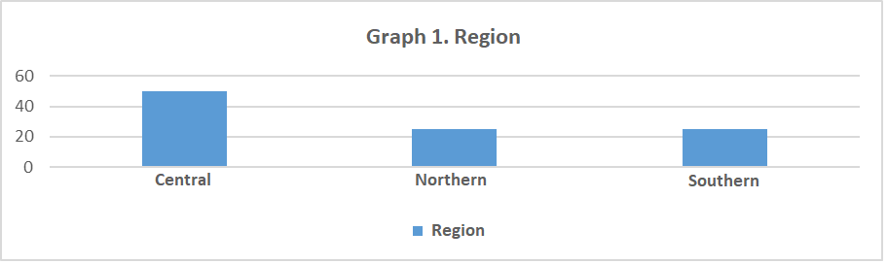
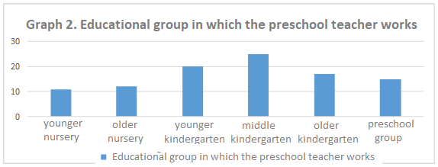
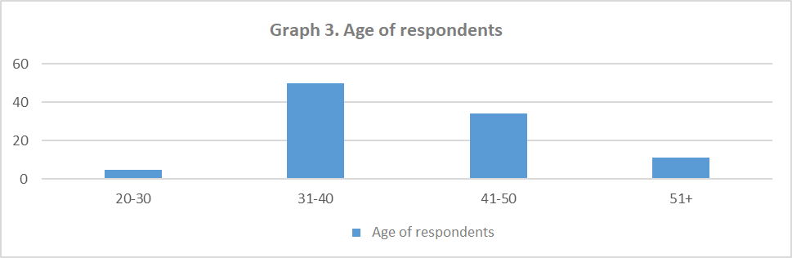
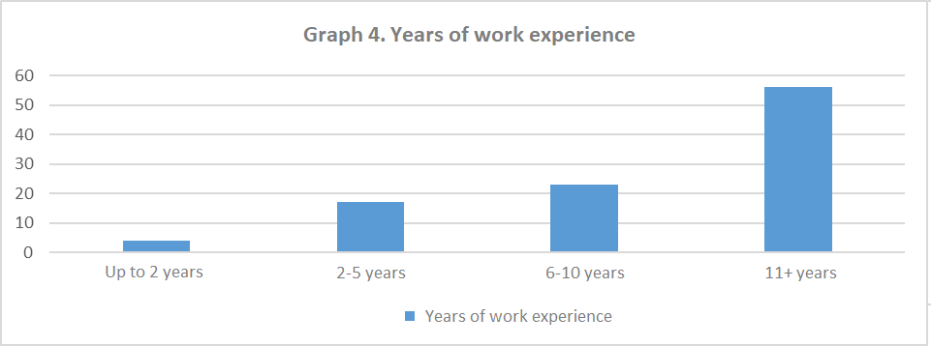
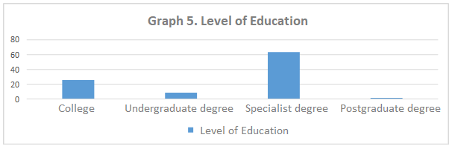
Since we did not want to limit the analysis to using only the data obtained through the questionnaire (however extensive it was), we opted for the qualitative segment of the research as well. This involved the organization of four focus groups, that is, focus group interviews, which gathered the respondents from all three regions in Montenegro. Respondents were preschool teachers, principals, expert associates and coordinators for continuing professional development in preschool institutions. The total sample of the focus groups was comprised of 36 respondents. Each focus group meeting lasted between 1 hour and 30 minutes and 2 hours.
The focus-group interview was half-structured in its character and covered five key issues or topics:
- How participants see the importance of professional training in Montenegro;
- How they assess the current situation in the area of ​​continuing professional training in Montenegro;
- Attitudes of the participants regarding the forms of professional development (which dominate, which are positive and which are negative sides, and the like);
- How do participants see the contents of the program of professional development (how much they respond to their needs for professional development);
- What recommendations do participants have regarding the system of professional development in Montenegro.
Interviews were also conducted with representatives of the Ministry of Education and the Bureau of Education in relation to the part of research aimed at collecting data related to the analysis of strategic documents, policies and relevant legislation.

VI Findings of the research and interpretation of results
Attitude toward the professional development
The following graph shows the answers of the respondents to the question about the factors which, in their opinion, have impact on the quality of educational work in the kindergarten.
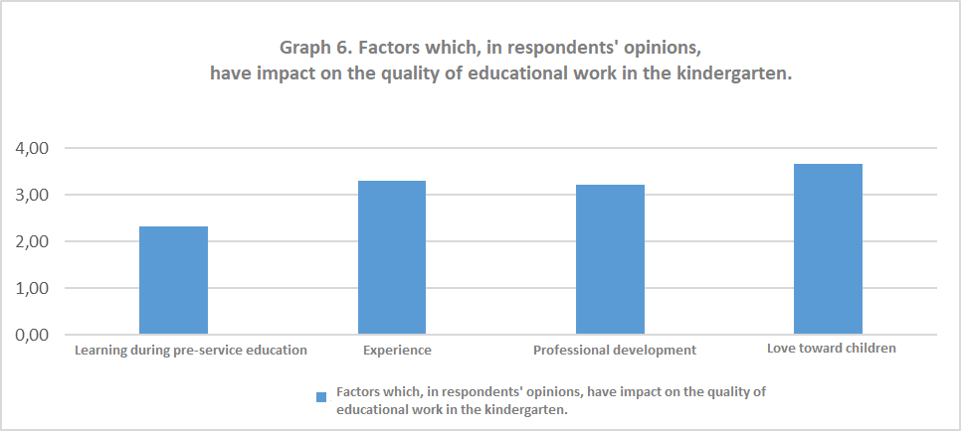
As we can see, the majority of respondents agree with the opinion that love toward children is key for a quality educational work with them. To a somewhat lesser extent, they think experience is crucial for a quality educational work with children, while even lesser number consider professional development to be a factor of quality. To a significantly lesser extent, respondents consider that their initial education is crucial for quality educational work with children.
Such evaluation of factors that are important for the quality work with children speaks of the dominance of the "romantic" image of a child (Kon, 1991), primarily seeing the child as a kind of emotional investment, which in itself excludes putting faith in learning and work on development of professional personality as elements crucial for quality educational work with children. In any case, professional development is not perceived as the most important factor affecting the success and effectiveness of their work.
Nevertheless, when it comes to the question of the impact of seminars and training on improving their practice, the respondents generally responded affirmatively. The following graph shows their evaluation of the importance and usefulness of seminars/trainings for improving their practice as preschool teachers.

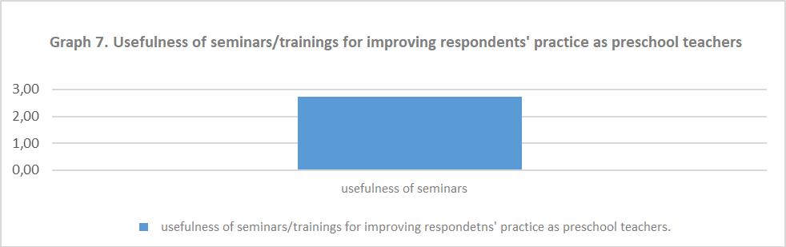
As we can see, preschool teacher predominantly find seminars and training programs as factors contributing to the improvement of their practice.
The next graph represents the views of preschool teachers regarding the question of contribution certain seminars or training programs to the improvement of their practice.
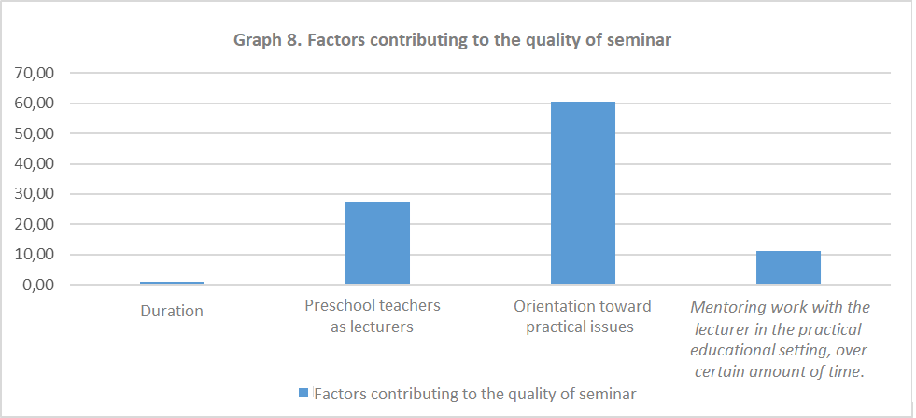
As we can see, the most significant number of respondents think that the contribution of the seminar to a specific practice depends on whether the seminar itself is focused on solving very concrete problems in practice, that is, on the actuality and relevance of the topic for the concrete educational group in which the preschool teacher works.
To a significantly lesser degree, but to a certain extent, efficiency is contributed by the fact who the lecturer is, especially if the lecturer is a practitioner himself (or at least was one). The effectiveness of the seminar is also contributed by the fact if the training involves some kind of work with the lecturer/trainer in the practical educational setting, over certain amount of time. A negligibly small percentage of respondents considers time, i.e. the duration of the seminar a factor affecting its effectiveness.
Focus group participants also pointed out that "it should be taken into account who should deliver seminars" (Participant 2, southern region).
The following graph gives an overview of the distribution of respondents' answers to the question of whether they know what the concept of reflexive practice is. We considered this issue particularly useful because understanding of reflexive practice is the basis of modern understanding of the role of preschool teachers in kindergarten as a learning community, and as an issue inextricably linked to their own understanding of their own profession, and potentially to their attitude towards professional development as such.
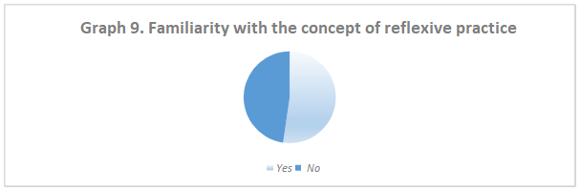

Although slightly more than 52% of respondents claimed that they knew what the concept of reflexive practice was, further analysis of their answers to the question how reflexive practice contributes to the quality of their work shows that there is essentially a small number of respondents who are familiar with its true meaning. About one third of respondents who claim to know what the concept of reflexive practice is did not provide an explanation of the term nor the way in which it affects their work. At the same time, significant part of answers was of a very general character, such as: "contributing to better work", "working better", "to understand children better" and the like. Some associated incorrect meaning with this term, such as "work based on instinct". In a very small number of questionnaires (in about 8% of them), we found comprehensive and accurate understanding of the process of reflexive practice, such as "a way to understand, to think and analyse the activities I have carried out", "allows me to look back and fix the mistakes in my work ","it allows me to turn my work into a challenge," and the like.
Our further analysis of responses to this question shows that there is a statistically significant relationship between the age group to which respondents belong and their understanding of the concept of reflexive practice (p = 0.001; χ ² = 15.612), in a way that the largest number of respondents belonging to the age group of 31-40 does know what the concept of reflexive practice is. We consider this to be indicative from the point of view of pre-service/faculty education of teachers, because it shows that it is closer to the "younger" generations, and that it is obviously present as a theoretical concept presented to them during their faculty education.
At the same time, we consider necessary to point out the fact that this very age group features the largest number of respondents who are not familiar with the concept of reflexive practice, even exceeding in number those who are. Taking into consideration the fact that almost 48% of respondents do not know what the concept of reflexive practice is, we consider this to be an alarming piece of information that turns out to be a problematic issue when it comes to the attitude of preschool teachers towards professional development and the understanding of one's own professional role, as well as understanding the kindergarten as a learning community.
The following graph gives presents the answers of respondents to the question of whether they know what the concept of the learning community implies.
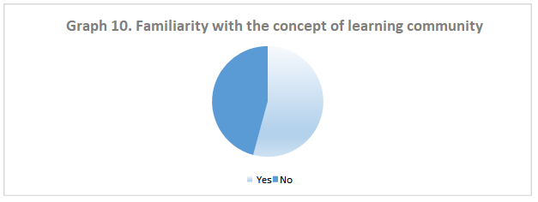
As it can be seen, more than a half of respondents knows what the concept of learning community is. On the other hand, more than half of them did not provide their own explanation of that concept nor stated how it influenced their work. At the same time, about 45% of them are not familiar with this concept. In several questionnaires, the "learning community" was associated with "peer learning", "learning from colleagues", "learning in community together with colleagues". Generally, we consider the fact that almost half of the respondents do not know what the concept of the learning community is as very indicative and then the question arises as to how they conceptualize kindergarten as an institution, as well as their own professional role and growth. This strongly emphasizes the need for a reassessment and a stronger work on the establishment of a kindergarten as a learning community, and a reassessment of their own professions as a developmental one, in Montenegro.
During the southern region focus group, the teachers emphasized that "the whole point is in team work" (Participant 2, southern region), and explained how they introduced the practice of working in teams: the inclusion team, the self-evaluation team, the team for entrepreneurship and the like, which proved to be a good practice. This speaks in favour of their recognition of the importance of creating a learning community, as the basis from which changes can be made. "Encouraging people to engage is as important as the internal organization of the institution" (Participant 1, southern region) - participants of this the focus group explicitly recognize the importance of the institution's internal organization as a learning community.
When asked about systematic observation practice, forms, techniques, frequency and its importance, about 40% of the questionnaires did not contain answers; the remaining questionnaires pointed to the finding that respondents were familiar with the forms and techniques of observation, that they considered them very important for getting to know children and hence to improve their work with them, but also that they use them mostly once or twice a year ("October-June"), which also indicates a kind of summative approach to systematic observation, as a method of evaluation, rather than a key tool of a reflective practitioner in their everyday work.
General data on the participation of respondents in the system of continuing professional development
The following graph presents the assessment of the level of teachers' agreements with each of the offered statements, which relate to their general assessment of the professional development system in Montenegro.
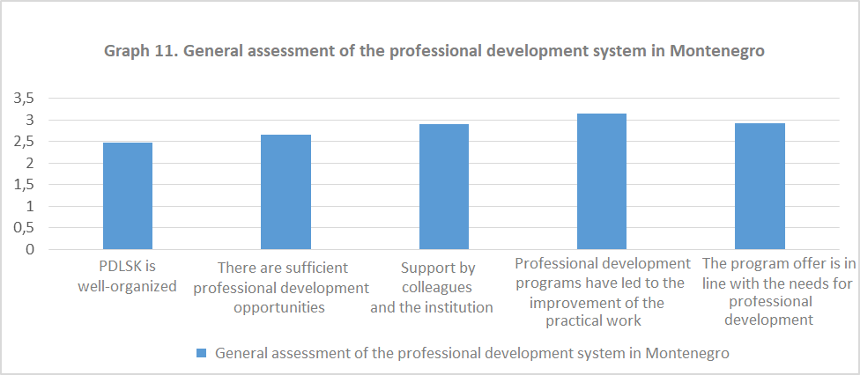
The highest degree of consensus in respondents related to the claim that the professional development programs in which they had participated improved their practice. In this way, they confirmed their earlier views that trainings and seminars were considered useful and effective to the quality of their own practice. However, it is important to note the fact that a large number of participants of such seminar assess the quality of CPDLS from the level of the specific institution in which they work, and not from the system level, i.e. that they were mostly satisfied with the program of professional development organized at the institution level, while they most often expressed dissatisfaction with the system of professional development organized by the Department for Continuing Professional Development at the Bureau of Education, as proven by the findings from the focus group discussions.
They, also, largely agree with the view that the professional development programs offered correspond to their training needs, and that they have the support of the institution and colleagues to further professionalize themselves. They partly agree with the view that they have sufficient opportunities for professional development, and also partly agree with the view that the system of professional development in Montenegro is well organized.
Participants from the focus group from the southern region pointed out that "it is necessary to find a way to motivate teachers to engage in the continuing professional development at the level of educational institution, because in addition to working with a large number of children in the groups and keeping extensive records of work, including portfolios for each child, it is difficult to expect a greater level enthusiasm in the CPD area" (Participant 4, southern region). It was also stated that "the CPD at the level of educational institution was well designed and that the teachers showed a greater interest in the first years of that program" (Participant 4, the southern region).
Similarly, during the discussion on seminars and the correspondence of topics with the needs of professional development, participants emphasized that "topics are not adapted to the kindergarten" (Participant 5, southern region). The focus group from the central region shared a general opinion that there is a number of preschool teachers who attend various seminars that are incompatible with their profession and current position in order to acquire senior professional degrees. The focus group from the north emphasized that "the topics or contents presented to them at seminars and other forms of professional development initiatives are mostly repeating, the same seminars with same lecturers are organized several times. Although the Catalogue features a large number of seminars, out of that number only several are organized frequently" (Participant 5, northern region). This, once again, brings up the question of the criteria for selecting or imposing a certain number of seminars. Focus group from the northern region pointed out that there were "very few topics for preschool education" in the Catalogue, and that many of them were "inadequate" and that the issue of relevance can be raised (Participant 4, northern region).
Focus group from the central region emphasized that "the level of awareness about the professional development is still not at the level that it should be. By this, we mean that the license is the main driver for most teacher to engage in professional development ("Is it a program leading to license? Is the seminar accredited? Do I have to attend it?"), and not a personal need for training and new knowledge and experience " (Participant 1, central region). However, it was also said that "younger preschool teachers have a more developed awareness of the importance of professional development, while older preschool teachers (mostly those with more than 10 years of working experience) are not enthusiastic about it, as they believe that the years of experience in kindergarten allowed them to gain enough experience and that seminars would not help them to learn anything new" (Participant 2, central region).
Focus group from the northern region pointed out that in Department for Continuing Professional Development "does not have any contact with kindergartens" (Participant 4, northern region), and that they do not listen to the needs of preschool teachers regarding professional development.
The following graph presents the data on the level of intensity of the participation of preschool teachers in various forms of professional development - seminars, focus groups, learning communities, hospitation, conferences, and the like.
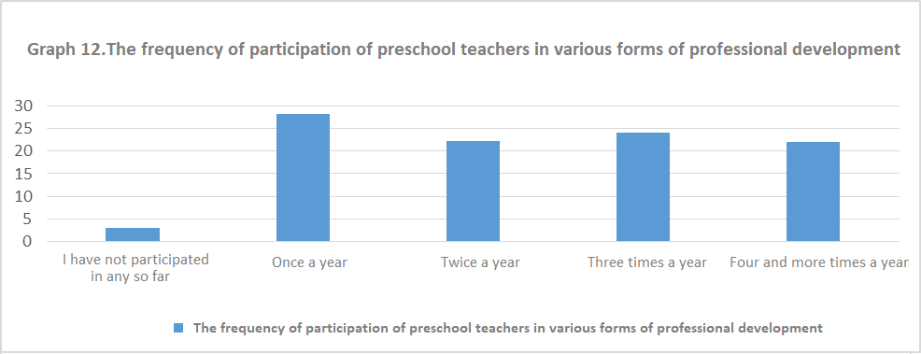
A little less than a third of participants normally attend some of the forms of professional development programs once a year. A little less than a quarter of them participate in professional development programs three times a year; about a fifth of respondents are involved in professional development two or four times a year. The percentage of those who do not participate in the professional development programs is rather negligible. These findings indicate that the level of intensity of professional development activity among the respondents is very low - we believe that it is not sufficient to participate in a professional development activity once, twice, or even three times during a year.
The following graph shows the intensity of attendance of seminars, as responded by the participants.
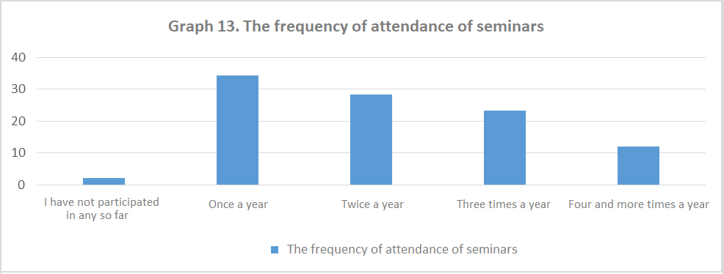
Around one third of respondents attend seminars once a year, while the same percentage of respondents attend them twice a year. Less than a fourth of them attend seminars three times a year. About 12% of respondents claim they attend seminars four times a year.
These two graphs actually point to the fact that, very likely, various forms of seminars themselves comprise a large share of professional development in general (given the similar percentages in responses). This entails, inter alia, the issue of a kind of controversy in the domain of philosophy and the perception of professional development, which refers to the fact that preschool teachers put equality sign between professional development and seminars, i.e. training programs. In this way, we find the findings presented in the previous two graphs more drastic, and we find that the level of intensity of professional development activities in which respondents participate is extremely low. Equally, we do not exclude the possibility that respondents participate in some form of professional development that they are not aware of as part of their professional growth activity (although this possibility has not been investigated during this research). Nevertheless, without any doubt, we can assume that professional development is often identified, or reduced to participating in seminars only.
A pedagogue from the focus group from the southern region pointed out that there is an expressed interest in seminars, and that "there are a lot of teachers who attend professional development seminars" (Participant 1, southern region).
When asked about the training programs that they had undergone during the last three school years, the respondents listed the following seminars (we quote them according to the frequency of responses, and we use the names given by the respondents, although some of the seminars are listed in the Catalogue under different names):
- "Education for sustainable development",
- "Introduction to entrepreneurship",
- "Entrepreneurial learning in the context of activity areas",
- "Observation for the purpose of monitoring child’s development",
- "Planning educational programs in preschool education",
- "Self-evaluation of pre-school institutions",
- "Working on child portfolio"
- "More than a play",
- "Through play to the knowledge in our little first-graders"
- "IDEP",
- "Observation for the purpose of monitoring child development",
- "Planning of educational work in kindergartens in accordance with the principles of the Program",
- "Multidimensional and individualized approach to learning and the overall development of children of early and preschool age"
- "NTC",
- "Working with children with the autism spectrum disorders",
- "Special Olympics" (Youth Athletes program)
- "Approach to child's creativity using contemporary methods",
- "Development of critical thinking",
- "Cooperation with family",
- "Encouraging enrolment and inclusion of children from rural areas in kindergartens"
- "Educational work in nurseries",
- "ECDL Seminar for Electronic Literacy",
- "Kindergarten without violence",
- "Eco-school",
- "Mentoring teacher trainees"
- "How to save teachers",
- "Drama method",
- "Inclusion of RE children in preschool institutions".
The following graph presents the distribution of respondents' responses to the question to select five of the eleven offered factors that positively influence their attendance of the seminar.
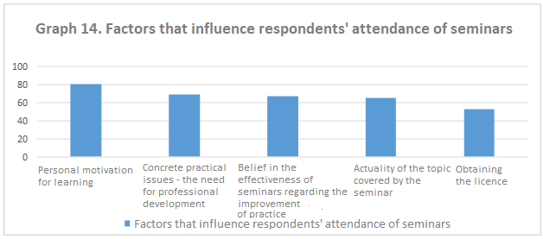
As it can be seen, the two most frequently reported factors indicate the existence of a particularly personal perspective on learning as such, stating that basic motivation for the respondents’ participation in the seminars comes from their essential need for learning. This is followed by factors related to the seminars themselves - the belief that the seminars are good for improving practice, and assessment of the actuality of the topic of the seminar itself. At the very end, more than 50% of respondents emphasize that obtaining of the license is the primary motivating factor to participate in seminars.
The sixth and seventh places are also occupied by the factors related to formal promotion - accreditation of the seminars, that is the ability to obtain the licence, as well as points, i.e. the possibility of promotion and acquiring senior professional degrees. (Since we asked respondents to rank the top five factors motivating their participation in the seminars, we did not present the remaining six factors in the graph at this point.)
Equally symptomatic is the fact that the incentives of employers, as well as the demands of a professional role (main preschool teacher, assistants, pedagogues, etc.) are the factors that least motivate teachers to participate in seminars (15% and 10%) - this finding is in line with the fact that the general culture of the educational institution as a "learning community" is not at a satisfactory level of development in Montenegro.
Our further analysis of this issue has shown that there is a statistically significant relationship between the participants' working experience and the factor related to the actuality of the topic of the seminar as a key motivating factor for participation (χ ² = 8.518; p = 0.036), in a way that those who have more work experience find the topic of the seminar a more motivating factor; it also shows that there is a statistically significant correlation between the work experience of respondents and the time factor, i.e. the duration of training as motivating for participation in seminars (χ ² = 10,739; p = 0,013), in the way that those who have more work experience do not find the duration of training motivating for their participation in professional development programs or seminars.
When it comes to obtaining a license as a motivating factor for the respondents’ participation in such seminars, it was also highlighted that "the conditions for obtaining a license should be determined taking into consideration the years of the work experience of the preschool teacher, since these should not be the same for preschool teachers with 5 years of service and those with 25 years of service "(Participant 1, southern region.)
During a focus group discussion, the issue of "only accredited seminars leading to licensing points, without acknowledging the seminars attended abroad, which should not be the case" was also raised (Participant 5, southern region). The same was noted by the participants from the central region - "there were a lot of quality seminars and programs in the past period, but not all of them were listed in the Catalogue, and therefore they were not accredited" (Participant 1, central region).
The focus group participants from the northern region emphasized that "professional development activities are mainly undertaken only to obtain the points necessary for the renewal of license" (Participant 1, northern region). Respondents from the central region only echoed this statement - external motivation dominates the scene, that is, obtaining the license is the predominant factor for participation in the seminars (focus group, central region).
The following graph shows the respondents' answers to the request to define five out of the eleven offered factors which, in their opinion, may be an obstacle to their participation i.e. attendance of seminars.
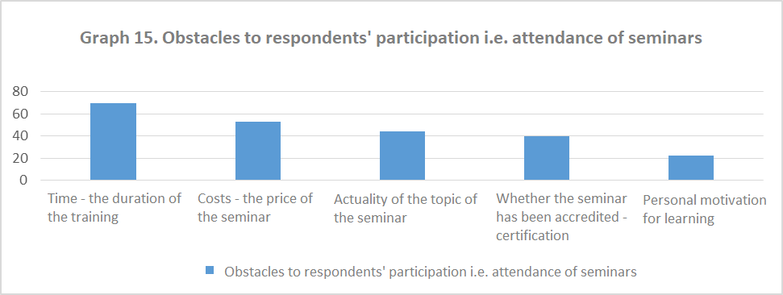
The analysis of respondents' answers shows that that the time, that is the duration of training remains a factor that is most often demotivating for their participation in seminars. Considering the fact that the majority of training programs in Montenegro include one-day or two-day seminars (usually lasting 8 working hours per day, see Catalogue of Professional Development Programs), and that very often they are being organized on weekends, it is clear that preschool teachers do not find this dynamic of work suitable. A rather obvious conclusion can be drawn here that a system of professional development should shift itself toward smaller forms of education, organized in a more frequent manner, and that seminar as the predominant form of education should have some kind of follow-up activity in terms of checking the application of newly acquired knowledge and skills.
More than 50% of respondents find that the price or the cost of the seminar is a factor that demotivates their participation in such programs. Namely, the prices of the seminars are significantly high compared to the relatively small income of preschool teachers, and apart from that there are rare examples when the institutions finance the participation of their staff in seminars. The fact that preschool teachers have never received systemic financial support for professional development based on their personal needs makes the whole issue even more problematic. It would be important to note, however, that there are training programs organized in kindergartens, for example, training for early intervention for children with disabilities which are organized by municipalities and delivered in local kindergartens, so there was no cost to preschool teachers and kindergartens. However, this fact does not significantly change the expressed attitude, because these were project activities by the Ministry of Education, UNICEF or the like, and not systematic solution for the issue of funding the continuing professional development of preschool teachers.
Similarly, 44% of respondents say that the actuality of the topic of the seminar has negative impact on their motivation to get involved in specific training programs. This also raises the question of the number of topics of the seminar that are in line with the needs of preschool teachers for training in certain areas.
During the focus group discussion with participants from the southern region, it was pointed out that their institution "has a problem that some preschool teachers do not attend seminars because they have to pay for them" (Participant 4, southern region). Also, participants from the focus group in the northern region, pointed out that "the big problem lies in the financing of seminars themselves, travel expenses of teachers, and that in the majority of cases educational institutions organize and finance them on their own" (Participant 2, northern region).

In addition to this, one of the key problems in the organization of the seminars is the "organization of various forms of professional development programs outside working hours, during the weekend or in the afternoons" (Participant 4, northern region). The fact that seminars are most often organized on weekends clearly indicates that there is an overall underdeveloped awareness of the need for continuing professional development, starting from the highest systemic level, through the institutional, to the personal level.

Identifying needs for professional development

The following graph presents the preschool teachers' responses to the question of whether they use the Questionnaire for Self-assessment of the Work of Preschool Teachers, as one of the basic mechanisms of the evaluation of one’s work and mapping the needs for professional development.
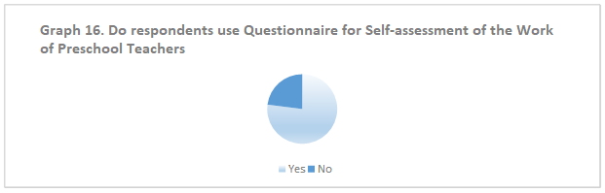

As we can conclude, 77% of respondents use the Questionnaire for Self-assessment of the Work of Preschool Teachers, while about 23% of them do not do that.
Participants from the central region, among other things, pointed out that "during the last teachers’ meeting in their institution, preschool teachers were introduced to the Self-Assessment Questionnaire" (Participant 3, Central Region).
When asked about the extent to which it helps them to recognize their strengths or weaknesses, i.e. their needs for improvement, respondents reported that it was helping them to a certain extent in the process, as can be seen from their responses presented in the following graph.
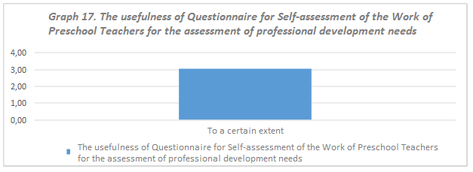
When asked how they assess their needs for professional development, in general, the following responses were obtained as presented in the next graph.
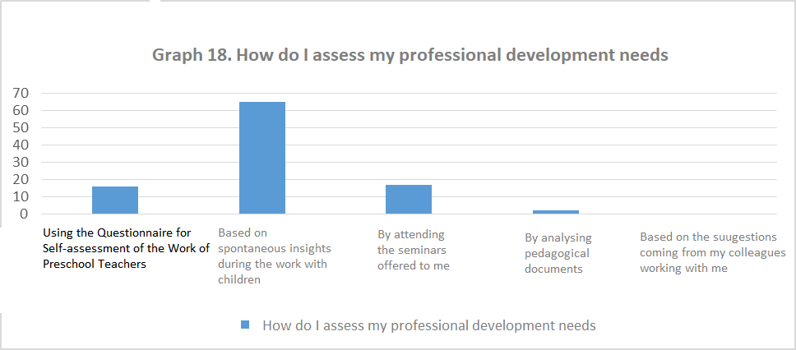
As we can see, 65% of respondents assess their training needs based on spontaneous insights made during their work with children. Only 16% of them claim that they do so based on the Questionnaire for Self-assessment of the Work of Preschool Teachers; about 17% of them simply attend seminars offered to them, regardless of their own need for professional development.
We find this finding genuinely alarming - the issue of true meaning of attending such seminars emerges, particularly if they are being randomly selected and do not meet the specific needs of preschool teachers for improvement. In addition, the finding indicating rather small number of those using the Questionnaire for Self-assessment of the Work of Preschool Teachers to assess their needs once again confirms the finding from the previous question, that this document is not particularly useful for identifying one’s needs, or at least it is not perceived as such.
In addition to this, the fact that a large number of respondents rely on spontaneous insights regarding the area they need to improve in their work suggests that the value of systematic observation has not been brought to life and that it is not considered as an integral aspect in the entire educational process. On the other hand, European experiences clearly point toward the fact that systematic observation and documentation are not only integral but rather key elements of the quality of educational work. As a result, for example, the Italian “Reggio Emilia” programme makes the document management a visible part of the overall effort of both the child and the preschool teacher in their efforts to gain certain knowledge and master certain skills, and also makes the learning process transparent. Documentation of a child's learning process does not only serve to reflect on the process that has taken place, but proves to be a good indicator for planning future educational goals and tasks. The entire process of documenting seeks meaningful and purposeful interaction with the child, as well as a reflection on the child's thinking process. It allows preschool teachers to make their work more effective, to make the educational process more open and more flexible, and help children gain wider and deeper understanding of certain terms and concepts.
Focus group participants from the southern region believe that there should be closer communication between the relevant educational institutions (kindergartens) and the Bureau of Education (Department for Continuing Professional Development), so that the latter could gain insight into the priorities, current topics of interest to the teachers, and what preschool teachers actually need: "It is important to have a conversation with preschool teachers, to hear their opinions, to counsel them, to have coordinators from the Bureau visit them and hear what preschool teachers have to say. This would make them motivated." (Participant 3, southern region).
Focus group participants from the southern region pointed out the importance of "the way the personal professional development takes place" and that it should "put emphasis on priority areas" (Participant 5, southern region). Focus group participants from the central region stressed that all preschool teachers have their "personal professional development plans for the next school year... The annual professional development report has been drawn up, but it has not been submitted to the Bureau of Education since no one has ever asked for these reports. Eventually, it has been added to the Annual Report on the Work of the Institutions "(Participant 3, central region). Other colleagues also concluded that "they did not send their reports to the Bureau because they have not been asked to do so, and that they kept records of professional development within their institution" (Participant 4, central region), or that "no one asked for reports and that they were properly kept and attached to the Annual Report that the Management Board adopts at the end of the school year" (Participant 5, Central Region). Focus group participants from the northern region also emphasized that preschool teachers "make personal plans each year" (i.e. personal professional development plans) (Participant 2, northern region).

Contents of professional development programs
The following graph gives an overview of the assessment of the importance of the listed aspects in the educational work of the preschool teachers for better quality of work with children.
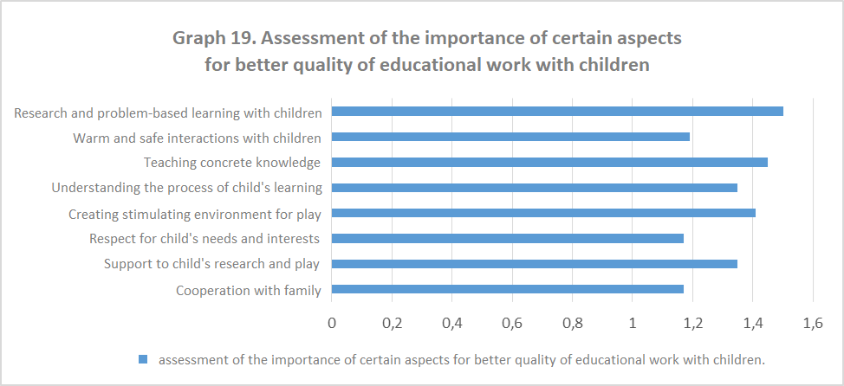
All the listed aspects were distributed by the respondents on the positive half of the continuum and assessed as important or very important (1 - very important, 4-not important). Particularly important for successful educational work are the aspects such as Cooperation with family, Respect for children’s interests and needs as well as Warm and safe interactions with children.
Even though all aspects were perceived as important, the least important, in the view of preschool teachers, appears to be Research and Problem-based learning with children - which is a finding that disagrees with findings from the Research on Effective Pedagogies (Siraj- Blatchford), which claim that the most effective pedagogical settings are those in which there is "sustained shared thinking", problem-based learning and research
A more detailed analysis of the responses has shown the existence of a statistically significant relationship between the degree education and assessment of importance of the aspects Cooperation with family (χ ² = 12,788; p = 0.047), Support to play and research (χ ² = 13,030; p = 0.043) and Understanding the child’s learning process (χ ² = 14.090; p = 0.021), implying that the higher the degree of education of respondents is, the more favourable they will assess the importance of the said three aspects. Here we can see that those who have a higher level of initial education predominantly recognise the importance of aspect of cooperation with family for the better quality of educational work with children.
The next graph presents the answers of respondents, i.e. their ranking of domains according their perception about the needs for further professional development.
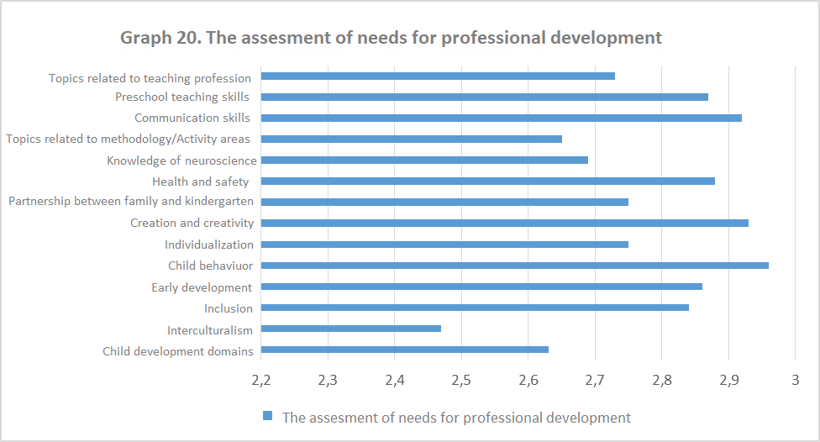

As can be seen, preschool teacher highlight the importance of professional development related to the topics of child behaviour, creation and creativity of children as well as topics from the domain of communication skills. These are followed by the need for training in the areas such as skills of preschool teachers, health and safety of children, early development and inclusion. The least necessary are considered to be topics in the area of interculturalism, as well as methodology related topics, that is, specific activity areas.
Following the further analysis of responses to this question, it was found that there was a statistically significant relationship between the group in which the preschool teachers work at the moment of research and the assessment of the importance of training in the domain of inclusion (χ ² = 25,911; p = 0,039), in a way that respondents who work in younger and middle groups in kindergartens highly appreciate the professional development in the field of inclusion. Similarly, there has been a statistically significant relationship between the group in which the preschool teachers work at the time of the research and the assessment of the importance of training in the field of understanding and managing child behaviour (χ ² = 26,364; p = 0,034), in a way that respondents who work in the middle group in kindergarten find the training in this domain essential.
The following graph shows their ranking of specific areas/topics of professional development that the respondents considered important for their current professional practice.
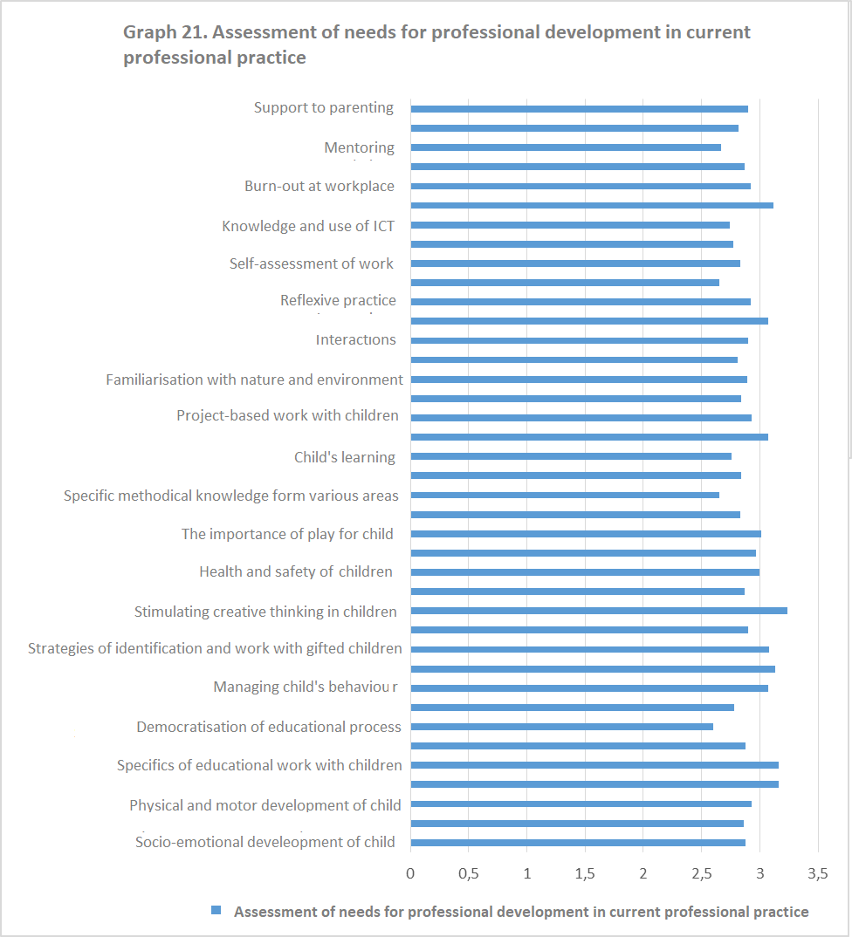

As we can see, respondents’ needs for professional development are mostly related to the domain of encouraging creative thinking in children, as well to the development of speech in children, and the domain of specifics of educational work with children with special educational needs. The area of positive discipline has also been assessed as important, as well the need for professional development in the domain overcoming professional stress. Furthermore, it has been perceived as necessary to work on improving the practice in the domains such as problem-based learning in children, observing and listening to children, managing child behaviour, the importance of play for child, health and safety of children, and specifics of early development.
A more detailed analysis of answers to this question led to the discovery of statistically significant relationship between educational groups in which respondents work and their assessment of needs for professional development in the domain of child’s socio-emotional development (χ ² = 25,156; p = 0,048). The need for professional development in this domain was especially prominent in respondents who work in the younger kindergarten groups. Furthermore, it turned out that there is a statistically significant relationship between educational groups in which respondents work and their assessment of needs for professional development in the domain of physical and motor development child (χ ² = 29.350; p = 0.014). The need for professional development in this domain was especially prominent in respondents who work in the younger and middle kindergarten groups. It also turned out that there is a statistically significant relationship between educational groups in which respondents work and their assessment of needs for professional development in the domains such as development of speech in children (χ ² = 26,035; p = 0.038) and positive discipline (χ ² = 26,035; p = 0.038). The need for professional development in this domain was especially prominent in respondents who work in the middle kindergarten group.
Further analysis proved the existence of statistically significant relationship between the age group respondents belong to and their assessment of needs for professional development in the domains of cognitive development of child ((χ ² = 22.305; p = 0.008) and planning activities (χ ² = 19,769; p = 0,019), in a way that age group 31-40 considers professional development in these domains very necessary.
Further analysis has shown out the existence of statistically significant relationship between years of working experiences respondents and their assessment of needs for professional development in the domains of partnership between family and kindergarten (χ ² = 18,505; p = 0,030), contemporary knowledge about brain development (χ ² = 19.326; p = 0.023), and specific methodological knowledge in certain areas (χ ² = 21,370; p = 0,011) in a way that those with more than 11 years of working experience consider professional development in these domains very necessary.
When it comes to specific topics of the seminar, focus groups participants pointed out that there were "very little seminars for gifted children " (Participant 2, southern region), and that "there are many problems with the behaviour of children... managing their behaviour is a problem" (Participant 3, southern region). In addition to these, topics related to the nursery age children also stand out, as well as the socio-emotional development of children (Participant 1, central region). The need for seminars on communication, inclusion, cooperation with parents, as well as the phenomena of burn-out and stress at work place and the like (focus group, northern region) were also emphasized. The participants from the northern region expressed their need for seminars that would tackle the topics of aggression, personal development - overcoming conflicts, the influence of media on children, problematic behaviour and managing behaviour in children (focus group, northern region).
Respondents were also asked to list five areas of their practice for which they feel they need advanced training in the upcoming period, as well as to list five areas for which they feel they have sufficient knowledge to work with children. The table below lists answers to both questions, according to the frequency of their appearance (we are listing them in their original form, as they were written in the questionnaires).

Needed topics/areas for professional development | Topics/areas for which I currently do not have the need for additional professional development
Project-based work with children | Inclusion
Positive discipline | Planning
Managing child behaviour | Entrepreneurial learning
Overcoming stress at work place | Mentoring
Professional burn-out phenomenon | Knowledge and use of ICT technology
Working with children with special needs | Work with children on projects
Development of speech in children | Music activities
Child fears | Documentation
Work in the nursery | Seminars on methodology
Early development | Fine arts and music
Use ICT technologies in kindergarten | Socio-emotional, physical, cognitive development of child
Partnership between family and kindergarten | Working with children from the RAE population
Communication skills | Working with children with the autism spectrum disorders
Training for using portfolios | Partnership between kindergarten and family
Identification strategies in working with gifted children
Physical and motor activities of child
Work in large groups
Documenting
Puppetry and child development through acting
"Hundred languages of the child"
Contemporary knowledge about brain development
Problem-based work with children
Child's socio-emotional development
Coaching
Learning community
Preschool teachers' teamwork
Thematic planning

In accordance with our earlier findings, preschool teachers expressed their explicit needs for additional knowledge in the domain managing child behaviour and discipline in the educational group, and that need, very probably, stems from the fact that educational groups are too large. The knowledge related to overcoming stress at work, dealing with the phenomenon of burnout at the workplace, as well as the need for support from colleagues and the community, expressed through the expressed interest for professional development in terms of the learning community, and teamwork, seem to be on the same page with the previous needs. Project-based work with children and problem-based work with children, as well as recent findings in the area of ​​development of children's brain, and in general, early development, are also listed as needed by preschool teachers. Of course, the topics that are always actual and interesting to learn about, as recognized by the preschool teachers themselves, are those related to the development of speech in child, as well as those related to social and emotional and physical, i.e. motor development of children. Preschool teachers also express the need for knowledge in the field of cooperation between the educational institution and the family, which is in line with the European tendencies and recommendations. Although preschool teachers expressed the need for professional development in the domain of work with children with special needs, at the same time they very clearly underlined that new knowledge in the field of inclusion was not needed. This contradiction really has to do with the great complexity of this domain - we are convinced, however, that additional knowledge of inclusive pedagogy is more than welcome in every preschool teacher, but that the emphasis should be on very specific forms of working with children of different special needs, and not on the general issues of inclusive pedagogy. The planning of educational work, entrepreneurial learning, the use of ICT technology, and seminars on methodology have not been recognized as areas in which they currently need further training. The explanation of why some seminars have been found 'unnecessary' can be found in the fact that in the past few years a lot of attention has been paid to these areas, and that the preschool teachers believe that they have sufficient competencies in these areas at this moment.

Forms of professional development
Next graph shows ranking of different forms of professional development according to the frequency of attendance by respondents.
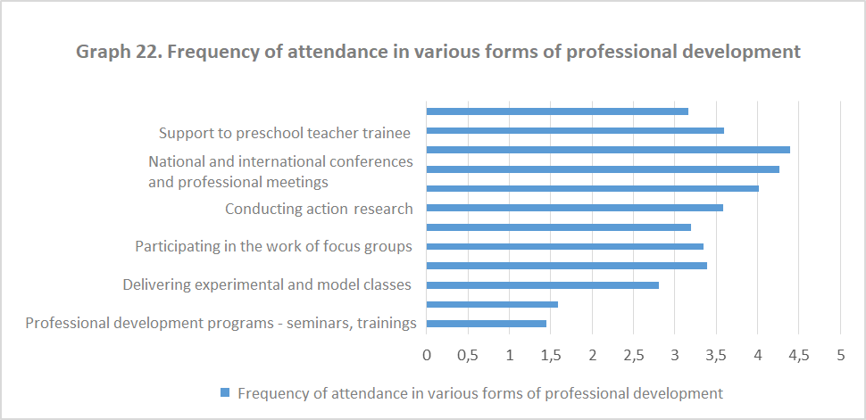
Forms of professional development in which respondents usually take part are professional development programs, as well as the use of professional literature and others sources of knowledge. These are followed by the delivery of experimental and model classes, coaching (professional development along with competent colleagues) and participation in the round tables, panel discussions, and presentations in the institution. Preschool teachers to a degree rarely participate at the national and international conferences, ICT-based training programs, mentoring, implementation of action research and the like.
Further analysis of answers to this Question has shown a statistically significant relationship between the years of working experience of preschool teachers and the intensity of their participation in the provision of support to preschool teacher trainees (mentoring) (χ ² = 37,906, p <0,001) and their participation in coaching - learning and developing with more competent colleagues (χ ² = 25,833, p = 0,011), in a way that those with more than 11 years of working experience most frequently participate in these forms professional development .
The following graph shows the assessment of the usefulness of some forms of professional development by preschool teachers.
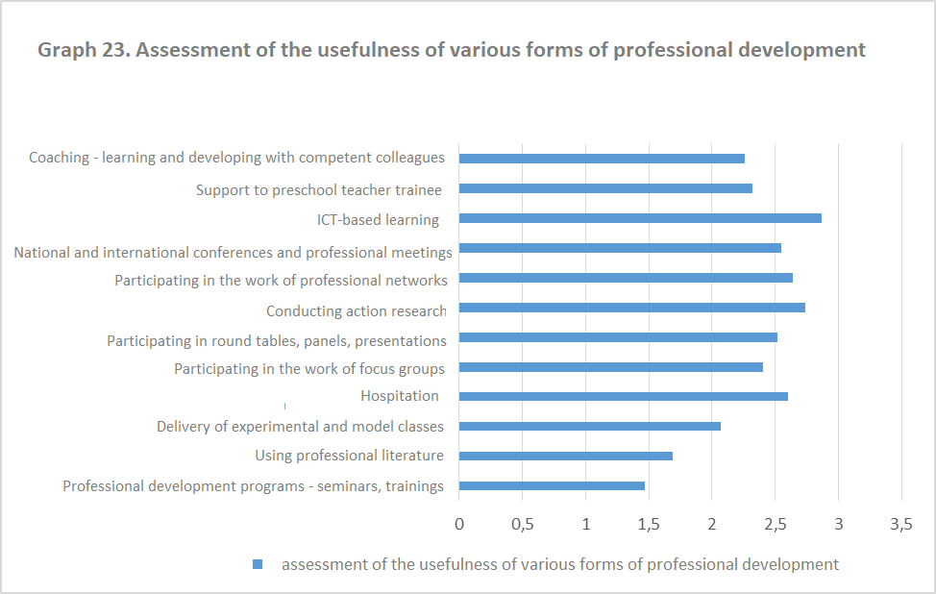

Respondents find the most useful the following forms of professional development: professional development programs - seminars, trainings, the use of literature and others sources of knowledge as well as the delivery of experimental and model classes. Also, to a significant degree they find hospitation, coaching and mentoring as particularly useful. The least useful they find professional development based on the use of ICT, as well as implementation of action research and participation in the work professional networks on all levels.
We consider rather symptomatic the finding that preschool teachers do not recognize the importance of action research as a process of professional growth and development.
Discussing the forms of continuing professional development, the focus group participants from the southern region stressed that it was important that "seminars were delivered by practitioners," and that "the teachers' meetings should be more substantive" (Participant 1, southern region). When it comes to seminars, the need for "a system of monitoring and assistance during the application of knowledge in practice, after the seminars, and before obtaining the certificate" was emphasized (Participant 4, southern region). In addition to this, it was said that it would be useful to "organize meetings of teachers in the institution once the seminar has been completed, during which the seminar participants could transfer their knowledge to their colleagues“ (Participant 6, central region).
It was also pointed out that "in the first years, preschool teachers showed greater interest, applied for the preparation and delivery of experimental and model activities, for internally implemented workshops on various professional topics, while the meetings of teachers within the institution served for the exchange of experience from practice... When the first three preschool teachers received senior professional degrees and when it was obvious that this brought an increase of just two euros in terms of their monthly salary, it was clear how much the system appreciated such degrees... Today, the increase in salary is about 20 euros for the first degree, which led to increase in the interest in the activities that bring professional points. Therefore, it would be a good thing to have some PDLSK activities taken into account when earning points for senior professional degrees, especially experimental and model ones, which represent a great opportunity for exchanging experiences and professional development" (Participant 4, southern region). The importance of the activities taking place within the institution, through the practice of the "learning community" has also been highlighted.
In addition, the focus group participants also said following: "We are rather inert, at the level of institution, for example, we are doing less than we could - for example, action research at the level of institution is not being conducted at all, even though it could be done" (Participant 1, central region). Obviously, the significance of those forms of professional development, as the basis of reflexive practice and leadership, is recognized. However, seminars continue to dominate the scene. As one of the recommendations, participants from the focus group in the central region put forward a proposal and expressed a "need for preschool teachers to be engaged in study visits" (Participant 2, central region) as one of the forms of professional development, as well as "participation in projects" which should be "accredited for the purpose of licensing preschool teachers "(Participant 3, central region).

VII Conclusions and recommendations
Conclusions

Based on the current insights into the practice and policy of professional development and professional development of teachers in Montenegro, based on the results of our research (including a survey, focus groups and interviews), and based on the findings of a large number of significant studies in this field, we could conclude that the system of professional development in Montenegro belongs to the ranks of industrial, i.e. mechanistic ones (according to the classification by Pavlović-Breneselović, Krnjaja, 2012), or as it is defined in the literature as neoliberal or managerial (Doecke, 2005). In the largest part, the professional development is implemented through training programs/seminars, is separated from practice, is subordinate to management by experts and is not fundamentally linked to the process of changing the whole institution, that is, kindergarten, into a learning community. In contrast to the mechanicist model, the systemic model of professional development departs from understanding educational systems as open, complex, multidimensional, dynamic, procedural, questioning systems that "search for meaning" (Banathy, 1991), and construct their purpose and meaning through the process of their own development. In the systemic model, teaching and learning are, by their very nature, collaborative processes that take place in a system of relationships. Teachers are seen as part of the community and their professional development is seen as an integral process of developing their own practice in the immediate context of working and improving practices of kindergartens/schools. The school, seen as a community, provides opportunities for the development of culture that promotes and encourages continuing learning as a form of shared experience that changes and perfects the practice of school/kindergarten (detailed elaboration of this models can be found in Pavlović-Breneselović, Krnjaja, 2012).
It is the approach to educational practice that sees each its segment as independent of others, and in which the professional development of preschool teachers is not seen as part of a larger whole - a learning community. We believe that the systematic model of professional development of teachers should be implemented (Kranjaja, Pavlović-Breneselović, 2013), as it implies the interaction of at least four supporting points - preschool teacher as a reflexive practitioner, kindergarten as a learning community, systematic changes and partnerships (between various stakeholders in professional development - the University, competent ministries, research institutes, non-governmental organizations, training centres, etc.).
Departing from these preliminary general insights, aiming to significantly increase the quality of the preschool part of educational system Montenegro, we hereby present the following conclusions:

Educational policy level

Although the system of professional development of preschool teachers/teacher has been established more than a decade ago, it seems that the system has not fully taken off, that the initial enthusiasm evaporated, that in a certain way it stalled at the Bureau of Education suffering from a small number of training program implementers. In order to be revived and improved, we believe it is necessary undertake the following steps:
- Legislation needs to be changed and improved, with the principal aim of making it affirmative and supportive, but also sufficiently binding. Detailed analysis of laws and rules regulating the field of professional development, licensing, and obtaining higher professional degrees, as well as the analysis of information obtained during the interviews and focus group discussions, led us to the general conclusion that the legislation is insufficiently precise, i.e. insufficiently elaborated, and therefore insufficiently binding when it comes to various aspects related to professional development and promotion of the educational staff.

- Professional development at the level of kindergarten needs to be promoted as a professional duty belonging to working hours - promoting the "child-free" hours (working hours outside the work in the educational group) during which the said activities would be carried out.

- Designing a series of promotional awareness-raising activities to draw attention to the importance and necessity of continuing professional development. This is based on the results of the survey that show that professional development is not seen as the most important factor that affects the success and efficiency of educational work. The research findings are supported by the fact that almost 48% of the respondents do not know what the concept of reflexive practice represents, which we believe to be an alarming fact which brings to light the problematic question of the attitude of preschool teachers towards professional development, and their understanding of their own professional role as well as perception of kindergarten as a learning community. We draw rather similar conclusion from the information obtained during the focus group discussions, which indicate an upsettingly high percentage of those not interested in professional development, and according to the assessment of colleagues from all four focus groups, we come to the conclusion that between 60% and 70% of preschool teachers are not interested in professional development programs. The findings from surveys and focus group further problematize the issue of awareness of the need for professional development and point us to the fact that such actions are frequently motivated by external factors (more than 50% of those who responded stressed that their participation in seminars was motivated by obtaining the license, and that during the selection of seminars they were guided by the following facts: accreditation of the seminar, the possibility of obtaining a certificate, as well as points, i.e. the possibility of promotion to a senior professional degree).

- Creating and implementing various strategies that should contribute to a quality educational system as a whole, and to a quality continuing professional development and training of teachers, who will be ready to respond to upbringing and educational challenges and demands of the society in transition, are some of the key issues discussed in the education circles in the majority of countries in Europe, as well as in Montenegro. However, when it comes to preschool education system in Montenegro, one of the key obstacles to quality professional development of preschool teachers can be found in the fact that there are too many children per nursery/kindergarten groups in most Montenegrin municipalities. Specifically, the number of children per educational group in school year 2017/2018 was 31.9. In general, in more than half of the municipalities in Montenegro, 56.52% to be precise, the average number of children per educational group exceeds the maximum envisaged by the legal norm - 25 children per educational group, in the group of children who are five to six year old (Podgorica, Herceg Novi, Danilovgrad, Budva, Petnjica, Plav, Cetinje, Tivat, Bar), which directly affects the phenomenon of 'burn-out' at work, reduces the possibility of organizing a quality educational process, leads to a decline in the motivation of preschool teachers for professional development and significantly prevents the implementation of newly acquired knowledge and skills of the preschool teachers in everyday practice.

- In order to raise new awareness of the importance of professional education of preschool teachers, it is be necessary to come up with new mechanisms of motivation. Of course, if the budget allows it, it would be desirable to introduce a mechanism for the financial rewarding of teachers who prove to be particularly active in the field of professional development. However, if the funding opportunities appear to be limited, other forms of rewarding can be introduced, such as study visits to other preschool institutions in the country and the region, support for participation in various meetings and conferences, allowing a number of free days to preschool teachers based on special merits and their efforts invested in professional development.

Whole-system level
- If the development of the whole educational system would be financially possible, it would be desirable to consider the establishment of regional teacher training centres (e.g., in the north, in Podgorica, in the south) which would continuously and professionally provide professional development services, being thriving and constant cores of innovative and contemporary knowledge from different domains of educational work. A quality example of a system of dissemination of continuing professional development can be found in Israel. The system of professional development of teachers in Israel belongs to the category of significantly decentralized systems operating through the network of teacher training centres (PISGA). These centres are integral parts of the whole educational system, their work and activities are coordinated by competent organs, while their annual programs and plans of activities are determined based on the needs expressed by the ministry and other competent institutions, schools and kindergartens, professional teachers’ associations, and based on the individually expressed needs of teachers themselves. The professional development programs are realized through four types of activities: group trainings/seminars initiated by the ministry in order to implement new educational policies; target-oriented seminars initiated by the managers of educational institutions; trainings/seminars created to respond to the individual needs of teachers, and personal seminars aimed at further professional development of teachers.
(more information available at: https://www.icesi.edu.co/relaciones_internacionales/images/Professional_Development_for_In-Service_Teachers_PISGA.pdf%20

- Even though the preschool institutions are often left to themselves when it comes to the professional development of preschool teachers, there are some encouraging information obtained during the focus group discussions regarding the significant number of examples of quality preschool teacher training programs at the level of pre-school institution. In support to this, it is important to note the fact that a large number of participants of such seminar assess the quality of CPDLS from the level of the specific institution in which they work, and not from the system level, i.e. that they were mostly satisfied with the program of professional development organized at the institution level, while they most often expressed dissatisfaction with the system of professional development organized by the Department for Continuing Professional Development at the Bureau of Education, as proven by the findings from the focus group discussions. Therefore, we think it would be necessary to establish systemic mechanisms of networking and exchanges among preschool institutions and preschool teachers, and to make that kind of professional development recognized and valorised in legal terms as well. A high quality example of networking and exchange at the level of preschool institution can be found in Croatia (more information available at: https://www.bib.irb.hr/853298).

It is necessary to establish smoother and more efficient cooperation on the relation Bureau of Education - public preschool institutions, and set up quality mechanisms for determining the needs of preschool teachers in terms of their professional development. It has been frequently brought to the light during the focus group discussions that there is almost complete absence or insufficient level of communication p between the Department for Continuing Professional Development of the Bureau of Education, on the one hand, and the educational institutions themselves, on the other ("the topics or contents presented to us at seminars and other forms of professional development initiatives are mostly repeating, the same seminars with same lecturers are organized several times. Although the Catalogue features a large number of seminars, out of that number only several are organized frequently" or, for example, it has been pointed out that in the Department for Continuing Professional Development " do not have any contact with kindergartens, and the teachers' needs for training are not being taken into consideration" or, for example, "a big problem lies in the financing of seminars themselves, travel expenses of teachers, and that in the majority of cases educational institutions organize and finance them on their own"

In addition to this, one of the key problems in the organization of the seminars is the "organization of various forms of professional development programs outside working hours, during the weekend or in the afternoons" (Participant 4, northern region). The fact that seminars are most often organized on weekends clearly indicates that there is an overall underdeveloped awareness of the need for continuing professional development, starting from the highest systemic level, through the institutional, to the personal level.

- Echoing the previous conclusion, the need of preschool institutions and preschool teachers themselves to make the entire system of professional development closer to practice is very clear. It is expected to be a kind of a tool in their efforts to raise the quality of educational work. Namely, during the interviews with participants from all four focus groups, it was clear that there is a high level of dissatisfaction with the imposition of the so-called "offered" training programs, the inability of preschool institutions and preschool teachers to nominate as "offered" training programs that they recognize as necessary, while on the other hand it happens that a very small circle of trainers implement their training programs on a number of occasions. Accordingly, the state budget funds go to the so-called "offered" seminars, while pre-school institutions and preschool teachers themselves are often forced to fund training programs they consider necessary from their own institutional or personal funds. Also there is a general opinion that the magazine entitled "Professional Development of Teachers in Montenegro" one of whose goals was the promotion and support of the professional development of the educational staff, failed to achieve its original purpose - preschool teachers report they often sent articles and contributions that were never published, while on the other hand, contributions of a the narrow circle of authors were published on a regular basis.

- In order to diversify the forms of professional development and make it more efficient, there should be a range of training programs for different types of professional development, such as coaching, action research, mentoring, etc.in order to avoid the formalization of these types of training and to ensure their effectiveness.

- As a matter of particular importance, perhaps even urgent one, emerges the issue of accreditation of professional development programs – of their authors, implementers, themes and the like. Namely, it appears as necessary for the competent institutions, primarily the Bureau of Education, to take serious steps in defining the quality criteria related to different previously mentioned aspects of the Catalogue of professional development programs.

- It also seems necessary to establish an effective mechanism for recognizing education acquired abroad, from reputable institutions and authors/implementers.

Contents of professional development programs

When it comes to the contents of the training programs implemented during the previous three years in Montenegro, and based on the analysis of the data obtained from the Ministry and the analysis of the Catalogue, the following findings are singled out as the most important:
- Implemented programs of professional development to a significant measure correspond to the domains that are recognized as urgent in the Strategy, as well as with the competency standards for preschool teachers in Montenegro.

- There is a tendency of increase in the number of programs that are dedicated to preschool teachers as professionals, in the broadest sense of the word.

- Areas which have been confirmed, by a large number of research, as those that particularly contribute to the effectiveness and quality of educational work, and which are not represented in programs implemented so far in Montenegro are: partnership between parents and kindergartens; interactions and teaching strategies and learning environment. In this respect, this can be considered as one of the key recommendations based on the previous analysis. We do acknowledge that this is certainly a very wide field of knowledge and improvement, and that there is potentially a very diverse array of seminars that can be organized in each of these three major areas.

- Also, the topic of reflexive practice is absent as one of the supporting syntagms of modern and effective educational practice, and it is certainly recommended that this be the thematic area for the future corpus of professional development programs.
Upon the analysis of the data obtained from the survey questionnaires and focus group discussions, we made the following conclusions and recommendations on the contents of the professional development program:
- Given that when it comes to the quality of their educational work with children, preschool teachers attach special importance to areas of cooperation with the family, respect for children's interests and needs, and warm and safe interactions with children, and given that these are the very recommendations in many European analyses of professional development of preschool teachers (see previous chapters and the results of the research that point to the impact of these aspects on the effectiveness of educational practice), we believe that these are the very areas which deserve to be offered to all preschool teachers.

- The explicit needs for professional development were highlighted in the following domains:
- Child behaviour- managing child behaviour, positive discipline, etc.,
- Creation and creativity - encouraging creative thinking in children,
- Socio-emotional development, physical and motor development - especially in younger and middle kindergarten group children;
- Development of speech and positive discipline - especially in middle kindergarten group children,
- Project-based work with children,
- Early development,
- Problem-based work with children,
- Overcoming stress in work, the phenomenon of burn-out at work place,
- Communication skills ,
- Partnership between family and kindergarten.

- From the responses obtained through the survey, as well as from the discussion with all four focus groups, it is clear that preschool teachers face more and more challenges related to managing child behaviour, and their socio-emotional development, discipline, etc. and therefore it is not surprising that they emphasize the needs for seminars related to early development, adaptation and socialization children in the kindergarten, development communication skills in preschool teachers, as well as seminars related to the problems such as burn-out and excessive exhaustion preschool teachers at the workplace.

- In line with the previous conclusion, the problem of too many children per educational group, which additionally complicates the work of preschool teachers, makes it difficult to create working atmosphere and individualize their educational work and activation all children – for this reason, professional development programs oriented toward the work in large groups in the next five year period would be more than welcome.
- In relation to the previous conclusion, a finding from the research points to the fact that preschool teachers do not recognize as particularly significant research and problem-based learning with children as factors that bring quality to educational work in kindergarten, which is in dissonance with findings of numerous research on effectiveness pedagogical work at an early age. In that sense we think it is necessary to underline the need for the affirmation of importance of problem-based learning and project-based learning as the most sophisticated forms of learning at the preschool age (Slunjski , 2012), and at the same time the need for the promotion of seminars i.e. professional development programs covering these topics.

We believe that a significant part of the training topics/programs identified through the analysis of the questionnaire and the information obtained through the focus group discussions should find their place in the Catalogue of Professional Development of Preschool teachers.
Forms of professional development and training

- Based on our analysis of the forms of professional development which took place in the previous three school years in Montenegro, and based on the insights into the research findings on the effectiveness of various forms of professional development, we draw the following preliminary findings and recommendations: Programs of professional development of preschool teachers in Montenegro that took place in the previous three years mainly involve condensed, one-day or two-day trainings of preschool teachers (excluding Outreach Preschool Services training, which in itself implied the training of future trainers, thus representing an untypical example of training, as well as the training for the Parenting for Lifelong Health Program).

- It can be said, that, in spite of the fact that the Strategy mentions other forms of professional development, in practice, nothing goeas far from the "traditional", linear notion of professional learning and development. Upon the reviewing the offer of professional development programs in the Catalogues, it is safe to say that the condensed, one-day or two-day training programs or seminars dominate. Graphs no. 12 and 13 show that it is very likely that a large share of the of different forms of professional development programs belongs to seminars (given the similar percentages of responses). This entails, inter alia, the issue of a kind of controversy in the domain of philosophy and the perception of professional development, which refers to the fact that preschool teachers put equality sign between professional development and seminars, i.e. training programs. In this way, we find the findings presented in the previous two graphs more drastic, and we find that the level of intensity of professional development activities in which respondents participate is extremely low. Equally, we do not exclude the possibility that respondents participate in some form of professional development that they are not aware of as part of their professional growth activity (although this possibility has not been investigated during this research). Nevertheless, without any doubt, we can assume that professional development is often identified, or reduced to participating in seminars only.

- The dominant choice of such forms of professional development is not in accordance with the findings of the effectiveness of programmes referred to in this section. We consider necessary to revise of the concept of professional development at all levels, and in particular to promote the offer of those forms of professional development that are more contextual, current and take place in concrete practice. In this regard, it is necessary to reconsider the issue of the designers of professional development program (in terms of the philosophy of professional development propagated by the dominance of one-day two-day seminars), including the question of the criteria for the selection of programs to be found in Catalogues.

Based on the data obtained through the survey questionnaire and focus group interviews, the following conclusions are drawn:
- Among the various forms of professional development, seminars/trainings are undoubtedly the most frequent. They are followed by the use of professional literature and other sources of knowledge, the delivery of experimental and model activities, participation in the work of round tables, panel discussions in the institution, etc. Since preschool teachers have expressed their confidence in the effectiveness of the seminars to improve their practice, this will continue to be one of the most frequent forms of professional development. Considering the fact that the offer of such programs is dominated by seminars, the results of the survey appear to be logical, which shows that preschool teachers perceive this type of training as very useful.

- Our respondents expressed their dominant opinion that the effectiveness of the seminar depends on the orientation of both topic and work toward concrete problems in practice, which leads us to the conclusion that it is necessary to adapt the seminars to the specific needs of specific preschool teachers (certainly, along with some more general topics).

- The second important factor influencing the effectiveness of a seminar, according to the findings of our research, is the lecturers - this leads us to the conclusion that it is necessary to take serious steps towards the upgrading of the system of professional development in the field of competencies of the authors/trainers, because, based on previous analyses and discussions in focus groups, we came to the conclusion that the situation is as follows - almost everyone can accredit a seminar on any topic, regardless of competency, because the accreditation process depends on fulfiling some formal elements related to the quality of the application form.

- The third crucial factor for the quality of a seminar is whether the seminar represents a kind of mentoring work with a lecturer who spends certain amount of some time preschool teachers doing practical work. This is an extremely important fact pointing to the need of reconceptualisation of existing trainings/seminars that are condensed "knowledge deliveries", without further follow-up, evaluation, monitoring implementation, etc.

- Although survey findings show that preschool teachers are familiar with the concept of action research, and that they have participated in them in their practice so far, it does not seem that we got get quality and honest answers regarding this issue. Namely, during the discussions in all four focus groups, we came to the conclusion that there have not been any action-related research in our preschool institutions, and that preschool teachers do not remember examples of their implementation. Therefore, the findings of the survey on this issue can be defined more as giving answers that the preschool teachers considered expected or desirable, rather than giving answers as responses that substantially reflect reality.

- Coaching or experiential guidance by more competent colleagues is not a common practice in the system of professional development in Montenegro, it is not defined in the legislation (regulations) nor present in the day-to-day practice in kindergartens. We believe that this kind of professional should be included in the system, made recognizable, and that certain degree of valorization should be introduced in the sense of obtaining points for licensing and obtaining higher professional degrees.

- Different types of innovative and research projects that are conducted at the level of the preschool institution itself or at the renowned institutes/higher education institutions or non-governmental organizations can be a very important and quality aspect of professional development, therefore we also believe that mechanisms for their recognition and valorization should be systematically developed.

- Child-free hours (working hours outside the educational group) represents an established practice in the education systems of developed European countries which clearly indicates a high degree of awareness of the need for professional development of preschool teachers that is not only declarative in its nature but precisely defined as regular work obligation that it takes place within the working hours of the preschool teacher.

Based on the previous analysis of the criteria for the selection of the program of professional development, we bring the following conclusions:
- The Bureau of Education does not collect professional development portfolios of individual institutions, which means they do not have data on self-evaluations, needs assessmens performed at the level of the institution, and the like. Therefore, we could not assess the extent to which the programs implemented so far correspond to the estimated needs at the level of the educational institution.

- The fact that there is no collection of documentation on the needs assessment at the level of individual institutions suggests that the needs as such are not considered as a significant criterion for the introduction of training programs in the Catalogue. Although the Professional Development at the School Level Manual proposes a system that makes possible to communicate the information about the needs from the level of practice to the Department of Continuing Professional Development, this does not seem to be practiced.

- Also, at this stage it is not possible to estimate how many offers of profesioanl developemnt programs (and not just realized programs) meet the needs of individuals or institutions as "learning communities".

- Based on the analysis of educational policy documents, we can establish that concrete professional development programs that have been implemented in the previous three years correspond primarily with the competency standards. However, the qualitative and quantitative analyses that followed have proven that the realized programs and in general the offer of accredited programs only partially correspond to the real needs of the preschool teachers; that at systemic level, the need for professional education of preschool teachers is more often assumed than actually established; and that there are many activities to be undertaken to establish key criteria for the selection of certain professional developement programs.

Recommendations

In accordance with the obtained results of the research and on the basis of the conclusions drawn, we make the following recommendations:

Education policy level
- It is necessary to improve legal regulations in the field of continuing professional development of teaching staff in the direction of greater commitment and affirmation, i.e. promotion of the importance of continuing professional development and provision of various legal mechanisms that will better link the improvements in the field with activities that the preschool teacher/teacher takes toward continuing professional development;

- It is necessary to harmonize secondary legislation with improved law (licensing regulation, rulebook on obtaining higher degrees, etc.), and in particular to change the rulebook on professional development in order to significantly improve catalogues of professional programs, diversify the forms of professional development, recognise different forms of training (seminars, workshops, lectures, action and other kinds of research, coaching, mentoring, the work of teacher teams, experimental and model activities - examples of reflexive practice, etc.), to introduce pedagogical guidance (in accordance with the recommendations of Peeters, J. (2016): Quality of ECE Service - Albania, Bosnia and Herzegovina, Kosovo, Montenegro, UNICEF which emphasize that professional development activities in Montenegro must be strongly associated with the practice, and that there is an urgent need to focus on the development of reflexive competencies in practitioners in pre-service education in the context of professional development activities (it is a method that begins with practice as it is at a given moment, then focuses on the objectives set out in the Strategy, collecting ideas for the change of existing practice, moving on to planning of specific innovations in order to eventually evaluate the change that has been made in pedagogical practice);
- It is necessary to to intensify and accelerate the already existing activities of the Ministry of Education in the field of establishing/constructing new kindergartens and putting existing buildings/premises into use by preschool institutions (which are currently used for some other purposes) in municipalities where the number of children per educational group exceeds the norm.
- It is necessary to to develop effective mechanisms for recognizing different program implementers in the country and abroad, to significantly raise the already defined criteria for accreditation of training programs, and to establish new criteria related to the competencies of program implementers;
- It is necessary to develop and implement a national strategy aimed at raising the level of awareness of the importance and necessity of continuing professional development of teaching staff;

Whole-system level

- It is necessary to reconsider the possibilities and, in line with tehm, work towards the establishment of regional centers for continuing professional development of teaching staff (Podgorica, north of the country, south of the country), with a network of municipal centers of excellence/quality in which further activities related to the continuing professional development of teaching staff could be disseminated, after clearly defining mechanisms for its functioning;

- It is necessary to design and determine financial mechanisms for the functioning of such a network of regional centers for continuing professional development and training of coordinators to run it;

- It is necessary to design and implement extensive activities related to the introduction and detailed information of educational institutions and teachers with the transformed and improved system of continuing professional development;

- It is necessary to transform and significantly improve the work of the Department for Continuing Professional Development of the Bureau of Education in terms of: a) better and more efficient servicing of the needs of educational institutions for continuing professional development, b) raising the level of quality and usability of the database on the implemented training programs, c) establishing effective mechanisms of continuing communication and exchange of information with educational institutions, d) establishing a flexible, efficient and continuing process of collecting and analyzing the needs for the continuing professional development of preschool teachers;

- It would be necessary to significantly link and synchronize the activities of the Department for Continuing Professional Development and the Quality Assurance Department, so that all activities related to continuing professional development could be significantly strengthened and that the activities of different departments of the Bureau of Education would not be in conflict;

Level of organization and implementation of programs and forms of training
- Design and implement the so-called follow-up to all training programs (evaluation of the training program, evaluation of the acquired knowledge, evaluation of the application of such knowledge in practice), which should definitely be a part of the regular activities in the context of coaching (experiential guidance by a more competent colleague);

- Organize regular annual consultations between principals of educational institutions, expert associates, continuing professional development coordinators in educational institutions, and implementers of seminars, on past and planned activities;

- Develop and organize training of all new implementers of accredited training programs;

- Define priority areas for continuing professional development on several levels: whole-system level, level of educational institution, individual level of preschool teachers;

- In line with the findings of this analysis, we recommend the development of a whole set of seminars/trainings (under the working title "Contemporary challenges in quality pre-school education"), with special emphasis on the following areas/training contents: child behaviour - managing child behavior, positive discipline, etc.; the specifics of educational work in early childhood/nursery age; creation and creativity - encouraging creative thinking among children, socio-emotional development and physical and motor development - especially in the younger and middle kindergarten group; speech development and positive discipline; Project-based work with children; Problem-based work with children; overcoming stress at work place, the phenomenon of professional burn-out; communication skills; partnership between family and kindergarten;

- Develop new and significantly improve to existing Internet services on the website of the Bureau of Education, intended for continuing professional development of teaching staff;

- Revitalize and transform online magazine "Professional Development of Teachers in Montenegro";

Reference
- Proposal for key principles of a Quality Framework for Early Childhood Education and Care, Report of the Working Group on Early Childhood Education and Care under the auspices of the European Commission, European Commission - Directorate-General for Education and Culture, 2014.

- CoRe Competence Requirements in Early Childhood Education and Care, A Study for the European Commission, Directorate-General for Education and Culture, Final Report, University of East London, Cass School of Education and University of Ghent, Department for Social Welfare Studies, 2011.

- Competent Educators of the 21st Century, ISSA’S PRINCIPLES OF QUALITY PEDAGOGY, ISSA, 2010.

- Roads to Quality, Strengthening Professionalism in Early Childhood Education and Care Systems, International Step by Step Association, 2015.

- Putcha, V. (2018). Strengthening and Supporting the Early Childhood Workforce: Competences and Standards. Washington, D.C.: Results for Development.

- Mitter, R. & Putcha, V. (2018). Strengthening and Supporting the Early Childhood Workforce: Training and Professional Development. Washington, D.C.: Results for Development.

- Peeters, J., Cameron, C. Lazzari, A., Peleman, B., Budginaite, I., Hauari, H., Siarova, H. (2015): Working conditions, training of early childhood care workers and quality of services – A systematic review, Eurofound, Publications Office of the European Union, Luxembourg.

- OECD (2012), Starting Strong III: A Quality Toolbox for Early Childhood Education and Care, OECD Publishing.

- OECD (2017), Starting Strong 2017: Key OECD Indicators on Early Childhood Education and Care, OECD Publishing, Paris.

- Peeters, J. (2016): Quality of ECE Service – Albania, Bosnia and Herzegovina, Kosovo, Montenegro, Unicef,

- Strategija ranog i predškolskog vaspitanja i obrazovanja u Crnoj Gori (2016-2020) (Early and Preschool Education Strategy for Montenegro (2016-2020)), Ministarstvo prosvjete Crne Gore, UNICEF,

- Standardi kompetencija za nastavnike i direktore u vaspitno-obrazovnim ustanovama, (Competency Standards for Teachers and Principals in Educational Institutions) Zavod za školstvo, Podgorica, 2016.

- Profesionalni razvoj na nivou škole/vrtića, Priručnik za nastavnike u školama, predškolskim ustanovama i domovima učenika (Professional Development at the Level of School/Kindergarten level, Handbook for Teachers in Schools, Preschool Institutions and Students' Dormitories), Zavod za školstvo, Podgorica, 2017.

- Teorija u praksi, Priručnik za profesionalni razvoj odgajatelja, (Theory in Practice, Handbook for Professional Development of Teachers) Pučko otvoreno učilište Korak po korak, 2012, Zagreb.

- Katalog programa stručnog usavršavanja nastvanika za školsku 2016/2017. godinu, (The Catalogue of Professional Development Programs for the School Year 2016/2017) Zavod za školstvo, Podgorica, 2016.

- Katalog programa stručnog usavršavanja nastavnika za školsku 2017/18. i 2018/19. (The Catalogue of Professional Development Programs for the School Years 2017/18 and 2018/19), Zavod za školstvo, Podgorica, 2017.

- Kalendari programa obuke u organizacij Odsjeka za KPR Zavoda za školstvo (The Calendar of Professional Development Programs organized by the Department for CPD of the Bureau of Education),
- http://www.zzs.gov.me/naslovna/profesionalnirazvoj/programi/Kalendar_programa_obuke_u_organizaciji_Odsjeka_za_/

- Southeast Asian Guidelines for Early Childhood Teacher Development and Management, SAMEO and UNESCO, Bangkok, 2016.

- Center for the Study of Child Care Employment (2008): Early childhood educator competencies: A literature review of current best practices, and a public input process on next steps for California; Berkeley, CA: Center for the Study of Child Care Employment, Institute for Research on Labor and Employment, University of California at Berkeley.

- Subotić, Lj., Grbović, S. (2012): Evaluacija sistema profesionalnog razvoja na nivou škole (2008-2011) (Evaluation of the System of Professional Development at the School level (2008-2011)), Zavod za školstvo.

- Siraj-Blatchford, I., Sylva, K., Muttock, S., Gilden, R., Bell, D. (2002): Researching Effective Pedagogy in Early Years, Queen’s Printer, London.

- Blair, C. 2002. School readiness: Integration of cognition and emotion in a neurological conceptualization of child functioning at school entry. American Psychologist 57(2): 111–27.

- Dahlberg, G, Moss, P., Pence, A. (2005): Beyond Quality in Early Childhood Education and Care: Postmodern Perspectives, London, The Falmer Press.

- Dahlberg, G., Moss, P. (2005): Ethics and Politics in Early Childhood Education, London, Routledge.

- Laevers, F. 2005. Well-being and involvement in care settings. A process-oriented self-evaluation instrument. Leuven University, Belgium: Kind & Gezin and Research Centre for Experiential Education.

- Rothbart, M. i M. Posner. 2005. Genes and experience in the development of executive attention and effortful control. U: New horizons in developmental theory and research, Ed. L. Jensen & R. Larson. San Francisco: Jossey-Bass.

- Shanker, S. 2009. Developing pathways: Scaffolding for early learners. www.bcssa.org/pro-d/conf-present/.../StuartShankerKeynote.ppt.
- Shonkoff , J. i D. Phillips. 2000. From neurons to neighborhoods: The science of early childhood development. Washington, D.C.: National Academy Press.

- Henderson, A. i K. Mapp. 2002. A new wave of evidence: The impact of school, family, and community connections on student achievement. Austin,Tex.: National Center for Family & Community Connections with Schools Southwest Educational Development Laboratory.

- Grossman, K., K. Grossman i P. Zimmerman. 1999. Attachment relationships in the context of multiple caregivers. In: Handbook of attachment: Theory, research, and clinical applications, Ed. J. Cassidy & P. Shaver. New York: The Guilford Press.

- Finn, J. i D. Rock. 1997. Academic success among students at-risk. Journal of Applied Psychology 82: 221–34.

- Pianta, R.C., K.M. La Paro i B.K. Hamre. 2006. CLASS: Classroom assessment scoring system manual for preschool (Pre-K) version. Charlottesville,Va.: Center for Advanced Study of Teaching and Learning. www.virginia.edu/vprgs/CASTL/.

- Slunjski, E. (2012): Tragovima dječjih stopa (Following Children's Footsteps), Profil International, Zagreb.

- Pavlović–Breneselović, D., Krnjaja, Ž. (2012): Perspektiva vaspitača o profesionalnom usavršavanju sa stanovišta sistemske koncepcije profesionalnog razvoja (Preschool Teachers' perspectives on Professional Development from the point of the systemic concept of Professional Development), Andragoške studije, str. 145-162.

- Krnjaja, Ž., Pavlović–Breneselović, D. (2013): Gde stanuje kvalitet (Where the Quality Lives), Institut za pedagogiju i andragogiju, Beograd.

- European Commission/EACEA/Eurydice/Eurostat (2014): Key Data on Early Childhood Education and Care in Europe. 2014 Edition. Eurydice and Eurostat Report. Luxembourg: Publications Office of the European Union.

- Zakon o predškolskom vaspitanju i obrazovanju Crne Gore. (The Law on Preschool Education of Montenegro)

- Lloyd-Jones, L. (2002). Relationship as curriculum. Head Start Bulletin, 73, 10–12. Retrieved January 10, 2008, from http://eclkc.ohs.acf.hhs.gov/hslc/ecdh/eecd/Domains%20of%20Child%20Development/Social%20and%20Emotional%20Development/ChildMentalHeal.htm#relcur

Preschool groups which are essentally elementary school preparatory programs, during the final year of kindergarten(Trans. note)
The document Evaluation of the system of professional development at the school level (2008-2011) provides aggregated data for schools and pre-school institutions, so in that sense we cannot make use of its findings.
As there is no generally accepted or typical translation of this term in the Montenegrin language, it is most often used in its original form. (Trans. note)

